Dynamic Programming

Table of Contents
Theory 3
What is Dynamic Programming? 3
Sample Code 3
LEVEL 1: Linear DP 6
1. Climbing Stairs (LC70) 6
2. Min Cost Climbing Stairs (LC746) 6
3. House Robber (LC198) 6
4. House Robber 2 (LC213) 6
5. Jump Game (LC55) 6
6. Decode Ways (LC91) 6
LEVEL 2: Multi-Dimensional DP 7
1. Vacation 7
2. Find Maximum length of valid subsequence 2 (LC3202) 7
3. Stone Game (LC877) 7
LEVEL 3: DP on Grid 8
1. Unique Paths (LC62) 8
2. Unique Paths 2 (LC63) 8
3. Minimum path sum (LC64) 8
4. Maximal Square (LC221) 8
Type 4: Knapsack 9
1. 0/1 Knapsack 9
2. Coin Change (LC322) 9
3. Coin Change II (LC518) 9
4. Subset Sum Problem 9
5. Partition Equal Subset Sum (LC416) 9
6. Partition with Given Difference 9
7. Last Stone Weight II (LC1049) 9
Type 5: Kadane’s Algorithm 10
1. Maximum Subarray 10
2. Best time to Buy or Sell Stock 10
3. Best time to Buy or Sell Stock II 10
LEVEL 6: String DP 11
1. Longest common subsequence 11
2. Print Longest common subsequence 11
3. Longest common substring 11
4. Minimum number of deletions and insertions 11
5. Longest Palindromic Subsequence 11
6. Minimum Insertion Steps to Make a String Palindrome 11
7. Shortest Common Supersequence 11
Type 7: DP on Subsequence 12
1. Longest Increasing Subsequence(LIS) 12
2. Largest divisible subset 12
3. Longest bitonic subsequence 12
4. Number of Longest Increasing Subsequence 12
LEVEL 9: Miscellaneous 13
1. K-ordered longest common subsequence 13
SOLUTIONS: 14
Type 1: Linear DP 14
TYPE 2: Multi-Dimensional DP 21
TYPE 3: DP on Grids 26
TYPE 4: Knapsack 30
TYPE 5: Kadane’s Algorithm 40
TYPE 6: String DP 42
Type 7: DP on Subsequence 50
Type 8: Miscellaneous 55

Theory

What is Dynamic Programming?
Dynamic programming (DP) is an optimization technique used to solve complex problems by breaking them down into simpler sub problems and storing the results of these sub problems to avoid redundant computations. It is particularly useful for problems with overlapping sub problems and optimal substructure properties.
Key Concepts of Dynamic Programming:
- Overlapping Sub problems: Solving the same sub problems multiple times.
- Optimal Substructure: The optimal solution to a problem can be constructed from optimal solutions of its sub problems.
- Memoization: Storing results of sub problems to reuse them, thus saving computation time. Also called top-down approach.
- Tabulation: Building a table in a bottom-up manner to store solutions of sub problems.

Steps to approach Dynamic Programming problems:
- Find the recurrence relationship
- Find the base case
- Find way to store solutions of sub problems

Sample Code
Q. https://leetcode.com/problems/fibonacci-number/
Fibonacci Series – Recursion:
def fib(n):
if n<=1:
return n
else:
return fib(n-1) + fib(n-2)

# fib : 0,1,1,2,3,5,8

print(fib(6)) #8

Here we see, our code is finding solution of same sub problems several time, which cause slowness. We can prevent this using DP, by saving solution of sub problems in an array.
Fibonacci Series –Top down:
Here we built solution from n to i, normally via recursion.

def fib_top_down(n, dp):
if n<=1:
return n
if dp[n]!= -1:
return dp[n]
else:
dp[n]= fib_top_down(n-1, dp) + fib_top_down(n-2, dp)
return dp[n]

n=6
dp = [-1]*(n+1)
print(fib_top_down(n, dp)) #8

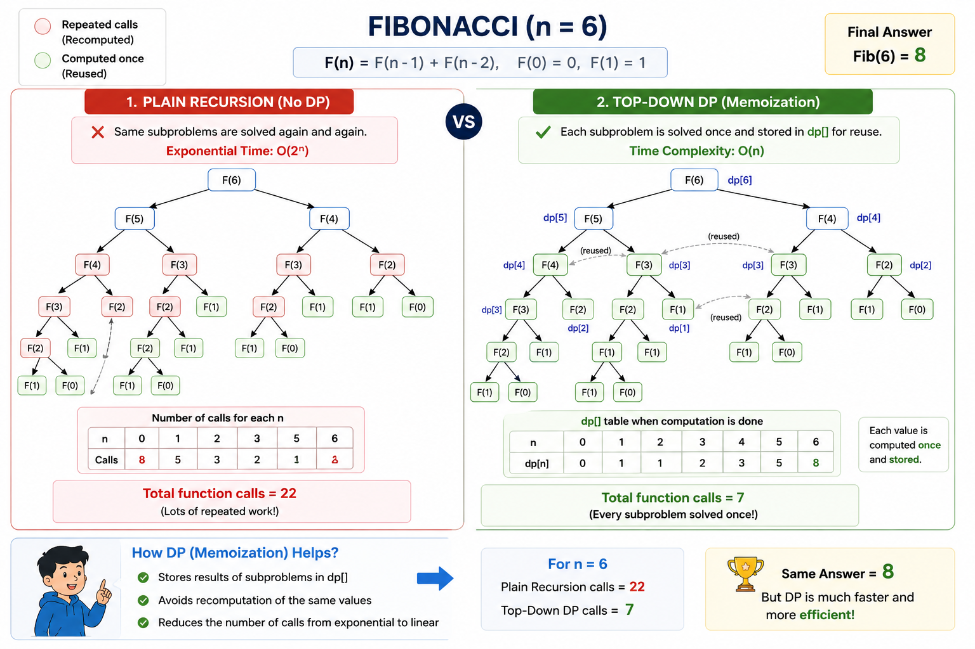

Fibonacci Series – Bottom Up:
Here we built solution from i to n, normally via loop.

def fib_bottom_up(n):
dp = [-1]*(n+1)
dp[0], dp[1] = 0, 1
for i in range(2,n+1):
dp[i] = dp[i-1] + dp[i-2]
return dp[n]

print(fib_bottom_up(6)) #8

Fibonacci Series – Bottom Up – Space Optimized:
In place of dp array we can use 2 variables for same purpose

def fib_bottom_up(n):
prev = 1
prev1 = 0
curr = 0

for i in range(2,n+1):
curr = prev + prev1
prev1 = prev
prev = curr

return prev

print(fib_bottom_up(6)) #8

LEVEL 1: Linear DP
For such questions you need to find the repetitive part of solution and improve it by saving result in array or somewhere, classic example is Fibonacci series. Also use when there is multiple way to do something and we need optimal way, min-max scenarios.

Climbing Stairs (LC70)
Link: https://leetcode.com/problems/climbing-stairs/

Min Cost Climbing Stairs (LC746)
Link: https://leetcode.com/problems/min-cost-climbing-stairs/

House Robber (LC198)
Link: https://leetcode.com/problems/house-robber/

House Robber 2 (LC213)
Link: https://leetcode.com/problems/house-robber-ii/

Jump Game (LC55)
Link: https://leetcode.com/problems/jump-game/

Decode Ways (LC91)
Link: https://leetcode.com/problems/decode-ways/

- Number of Dice Rolls With Target Sum (1155) LeetCode
- Minimum Cost For Tickets (983) LeetCode
- Solving Questions With Brainpower (2140) LeetCode
- Jump Game VI (1696) LeetCode
- Domino and Tromino Tiling (LC 790)

LEVEL 2: Multi-Dimensional DP

Vacation
Link: https://atcoder.jp/contests/dp/tasks/dp_c

Find Maximum length of valid subsequence 2 (LC3202)
Link: https://leetcode.com/problems/find-the-maximum-length-of-valid-subsequence-ii/

Stone Game (LC877)
Link: https://leetcode.com/problems/stone-game/

- Predict the Winner (486) LeetCode
- Remove Boxes (546) LeetCode
- Strange Printer (664) LeetCode
- Palindrome Removal (1246) LeetCode
- Out of Boundary Paths (LC 576)
- Knight Probability in Chessboard (LC 688)
- Number of Unique BSTs (LC 96)
- Unique Binary Search Trees II (LC 95) — construction variant
- Interleaving String (LC 97)
- Minimum Cost to Merge Stones (LC 1000) — advanced interval DP
- Matrix Chain Multiplication GeeksforGeeks (see video) [Difffernt section at end]
- Burst Balloons (312) LeetCode

LEVEL 3: DP on Grid
These problems involve navigating a 2D grid, making optimal decisions at each cell.

Unique Paths (LC62)
Link: https://leetcode.com/problems/unique-paths/description/

Unique Paths 2 (LC63)
Link: https://leetcode.com/problems/unique-paths-ii/

Minimum path sum (LC64)
Link: https://leetcode.com/problems/minimum-path-sum/

Maximal Square (LC221)
Link: https://leetcode.com/problems/maximal-square/

- Out of Boundary Paths (576) LeetCode
- Count Square Submatrices (1277) LeetCode
- Dungeon Game (174) LeetCode
- Cherry Pickup (741) LeetCode
- Cherry Pickup II (1463) LeetCode
- Number of Increasing Paths in a Grid (2328) LeetCode
- Paths in Matrix Whose Sum Is Divisible by K (2435) LeetCode

- Falling Path Sum (LC 931)
- Minimum Falling Path Sum II (LC 1289) — harder variant, no adjacent columns
- Number of Paths with Max Score (LC 1301)
- Path With Maximum Minimum Value (LC 1102)

Type 4: Knapsack
These problems revolve around selecting items with given weights and values to maximize or minimize a certain criterion.

0/1 Knapsack
Link: https://www.geeksforgeeks.org/problems/0-1-knapsack-problem0945/1

Coin Change (LC322)
Link: https://leetcode.com/problems/coin-change/

Coin Change II (LC518)
Link: https://leetcode.com/problems/coin-change-ii/

Subset Sum Problem
Link: https://www.geeksforgeeks.org/problems/subset-sum-problem-1611555638/1

Partition Equal Subset Sum (LC416)
Link: https://leetcode.com/problems/partition-equal-subset-sum/description/

Partition with Given Difference
Link: https://www.geeksforgeeks.org/problems/partitions-with-given-difference/1

Last Stone Weight II (LC1049)
Link: https://leetcode.com/problems/last-stone-weight-ii/

- Ones and Zeroes (474) LeetCode
- Perfect Squares (279) LeetCode
- Profitable Schemes (879) LeetCode
- Number of Ways to Earn Points (2585) LeetCode
- Tallest Billboard (956) LeetCode
- Combination Sum IV (LC 377) — unbounded knapsack, order matters

Type 5: Kadane’s Algorithm
Kadane’s Algorithm is a dynamic programming approach used to solve the Maximum Subarray Sum Problem — i.e., to find the contiguous subarray within a 1D array of numbers that has the largest sum.

Maximum Subarray
Link: https://leetcode.com/problems/maximum-subarray/description/

Best time to Buy or Sell Stock
Link: https://leetcode.com/problems/best-time-to-buy-and-sell-stock/description/

Best time to Buy or Sell Stock II
Link: https://leetcode.com/problems/best-time-to-buy-and-sell-stock-ii/

- Maximum Subarray (53) LeetCode
- Maximum Product Subarray (152) LeetCode
- Maximum Sum Circular Subarray (918) LeetCode
- K-Concatenation Maximum Sum (1191) LeetCode
- Maximum Absolute Sum of Any Subarray (1749) LeetCode
- Maximum Subarray Sum After One Operation (1746) LeetCode
- Maximum Alternating Subsequence Sum (1911) LeetCode
- Maximum Sum Circular Subarray with obstacles — GfG variant for extra drilling

LEVEL 6: String DP
These problems focus on operations over strings, such as finding subsequence or transformations.

Longest common subsequence
Link: https://leetcode.com/problems/longest-common-subsequence/description/

Print Longest common subsequence
Link: https://atcoder.jp/contests/dp/tasks/dp_f

Longest common substring
Link: https://www.geeksforgeeks.org/problems/longest-common-substring1452/1

Minimum number of deletions and insertions
Link: https://www.geeksforgeeks.org/problems/minimum-number-of-deletions-and-insertions0209/1

Longest Palindromic Subsequence
Link: https://leetcode.com/problems/longest-palindromic-subsequence/description/

Minimum Insertion Steps to Make a String Palindrome
Link: https://leetcode.com/problems/minimum-insertion-steps-to-make-a-string-palindrome/

Shortest Common Supersequence
Link: https://leetcode.com/problems/minimum-insertion-steps-to-make-a-string-palindrome/

- Palindromic Substrings (647) LeetCode
- Word Break (139) LeetCode
- Longest Common Prefix (non-DP baseline) LeetCode
- Edit Distance (72) LeetCode
- Delete Operation for Two Strings (583) LeetCode
- Distinct Subsequences (115) LeetCode
- Interleaving String (97) LeetCode
- Regular Expression Matching (10) LeetCode
- Wildcard Matching (44) LeetCode
- Scramble String (87) LeetCode
- Minimum ASCII Delete Sum (712) LeetCode
- Palindrome Partitioning II (132) LeetCode
- Minimum ASCII Delete Sum for Two Strings (LC 712)
- Word Break (LC 139)
- Word Break II (LC 140)
- Longest Repeating Substring — GfG (LC's version is Premium)
- Wildcard Matching (LC 44)
- Count Different Palindromic Subsequences (LC 730) — very hard
- Minimum Insertion Steps to Make a String Palindrome (LC 1312)
- Longest Valid Parentheses (LC 32)

Type 7: DP on Subsequence
- We are not restricted to contiguous elements (unlike Kadane or sliding window).
- We choose a subsequence by skipping or including elements while keeping order.
- State = "best solution ending at index i considering elements before it."

Longest Increasing Subsequence(LIS)
Link: https://leetcode.com/problems/longest-increasing-subsequence/description/

Largest divisible subset
Link: https://leetcode.com/problems/largest-divisible-subset/

Longest bitonic subsequence
Link: https://www.geeksforgeeks.org/problems/longest-bitonic-subsequence0824/1

Number of Longest Increasing Subsequence
Link: https://leetcode.com/problems/number-of-longest-increasing-subsequence/

- Longest Increasing Subsequence (300) LeetCode
- Number of Longest Increasing Subsequence (673) LeetCode
- Largest Divisible Subset (368) LeetCode
- Longest String Chain (1048) LeetCode
- Russian Doll Envelopes (354) LeetCode
- Longest Arithmetic Subsequence (1027) LeetCode
- Longest Arithmetic Subsequence of Given Difference (1218) LeetCode
- Longest Ideal Subsequence (2370) LeetCode
- Maximum Length of Pair Chain (646) LeetCode
- Bitonic Subsequence GeeksforGeeks
- Longest Common Subsequence (already listed under Type 3)
- Maximum Length of Repeated Subarray (LC 718) — continuous LCS variant
- Maximum Sum Increasing Subsequence — GfG (LIS variant not directly on LC)
- Delete Operation for Two Strings (already listed under Type 3)
- Minimum Number of Deletions to Make a String Palindrome — GfG (LC 1312 covers insertions; this is the deletion-framing companion)

LEVEL 9: Miscellaneous

K-ordered longest common subsequence
A k-ordered LCS is defined to be the LCS of two sequences if you are allowed to change at most k elements in the first sequence to any value you wish to. You are given 2 integer sequences and a number k. You can make max k changes in sequence 1 to get maximum LCS, find the max length of LCS.

- Palindrome Partitioning 2
Link: https://leetcode.com/problems/palindrome-partitioning-ii/description/

- Longest Path
Link: https://atcoder.jp/contests/dp/tasks/dp_g

- Divisor Game (1025) LeetCode
- Stone Game (877) LeetCode
- Knight Dialer (935) LeetCode
- Knight Probability in Chessboard (688) LeetCode
- Domino and Tromino Tiling (790) LeetCode
- Best Time to Buy and Sell Stock with Cooldown (309) LeetCode
- Best Time to Buy and Sell Stock with Transaction Fee (714) LeetCode
- Best Time to Buy and Sell Stock IV (LC 188) — k-transactions state DP
- Freedom Trail (514) LeetCode
- Super Egg Drop (887) LeetCode
- Minimum Cost to Cut a Stick (1547) LeetCode
- Partition Array for Maximum Sum (1043) LeetCode
- Count Vowels Permutation (1220) LeetCode
- Arithmetic Slices II (446) LeetCode
- Student Attendance Record II (552) LeetCode
- Maximum Product of Word Lengths — bitmask, GfG-style framing (LC has a bitmask version, LC 318)
- Partition to K Equal Sum Subsets (LC 698) — DP + bitmask hybrid
- Minimum Number of Refueling Stops (LC 871) — DP variant (also solvable greedily)
- Paint House (LC 256) — state-based DP
- Paint House II (LC 265) — k-colors variant, harder state tracking
- Race Car (LC 818) — very hard, BFS+DP hybrid

SOLUTIONS:

Type 1: Linear DP

- Climbing Stairs
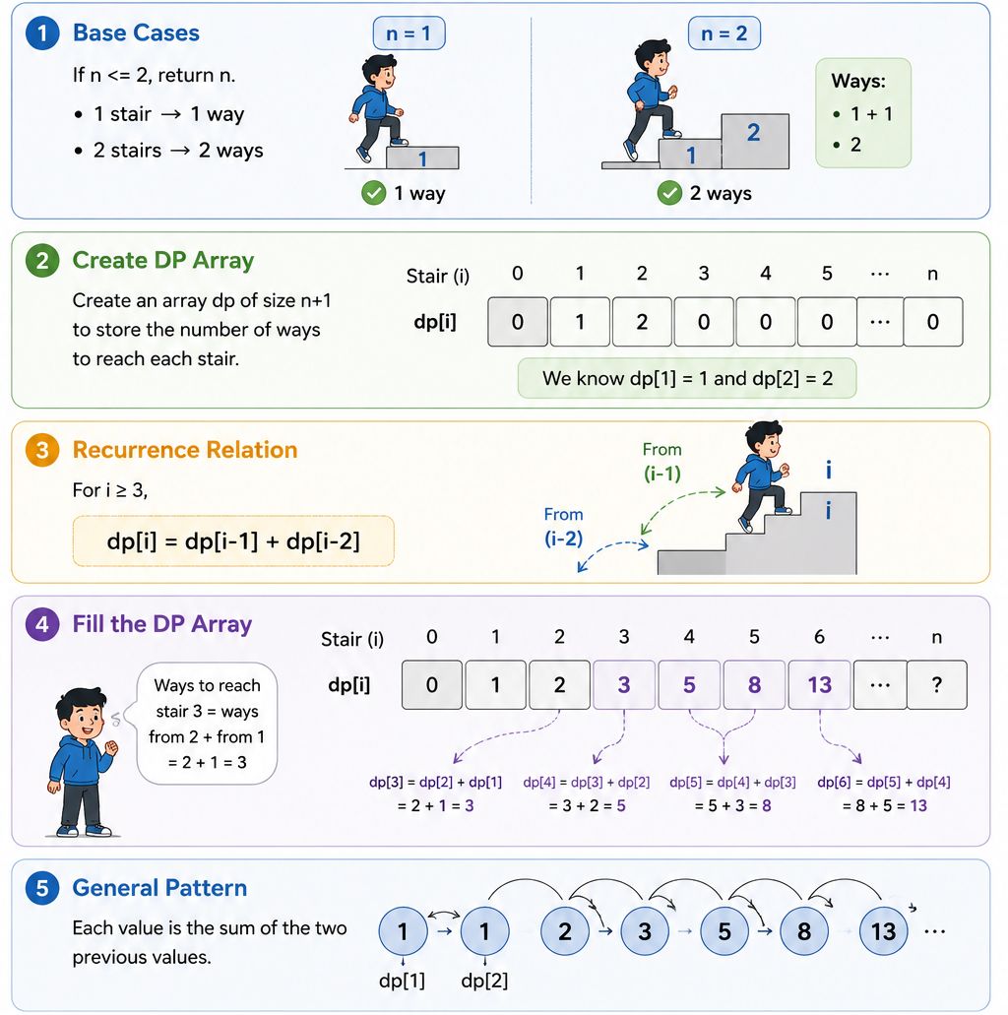

class Solution:
def climbStairs(self, n: int) -> int:
if n<=2: return n #ways for 1 and 2 steps are 1 and 2 resp
dp = [0]*(n+1)
dp[1], dp[2]=1,2

# ways to climb nth stair = ways from n-1 + ways from n-2
for i in range(3,n+1):
dp[i] = dp[i-1] + dp[i-2]

return dp[n]

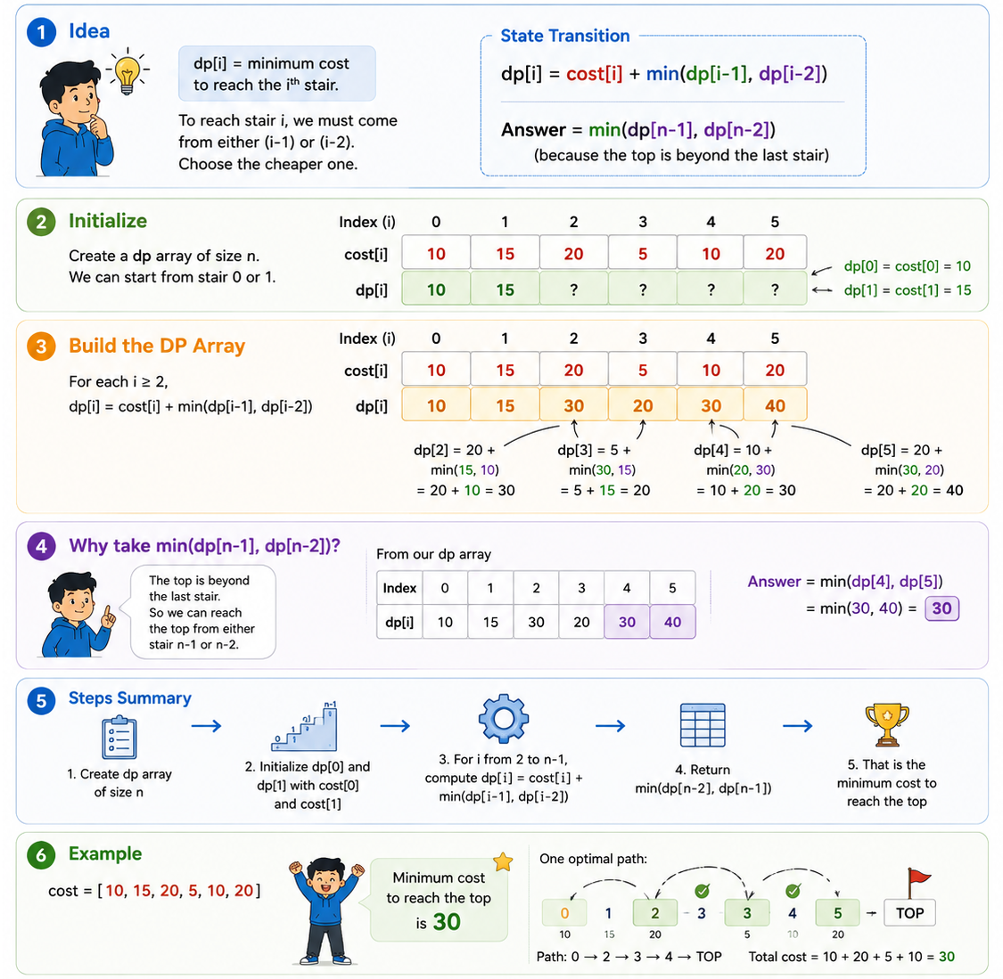2. Min Cost Climbing Stairs

class Solution:
def minCostClimbingStairs(self, cost: List[int]) -> int:
n=len(cost)
dp=[0]*n
dp[0]=cost[0]
dp[1]=cost[1]

for i in range(2,n):
dp[i] = cost[i] + min(dp[i-1],dp[i-2])
return min(dp[-1],dp[-2])

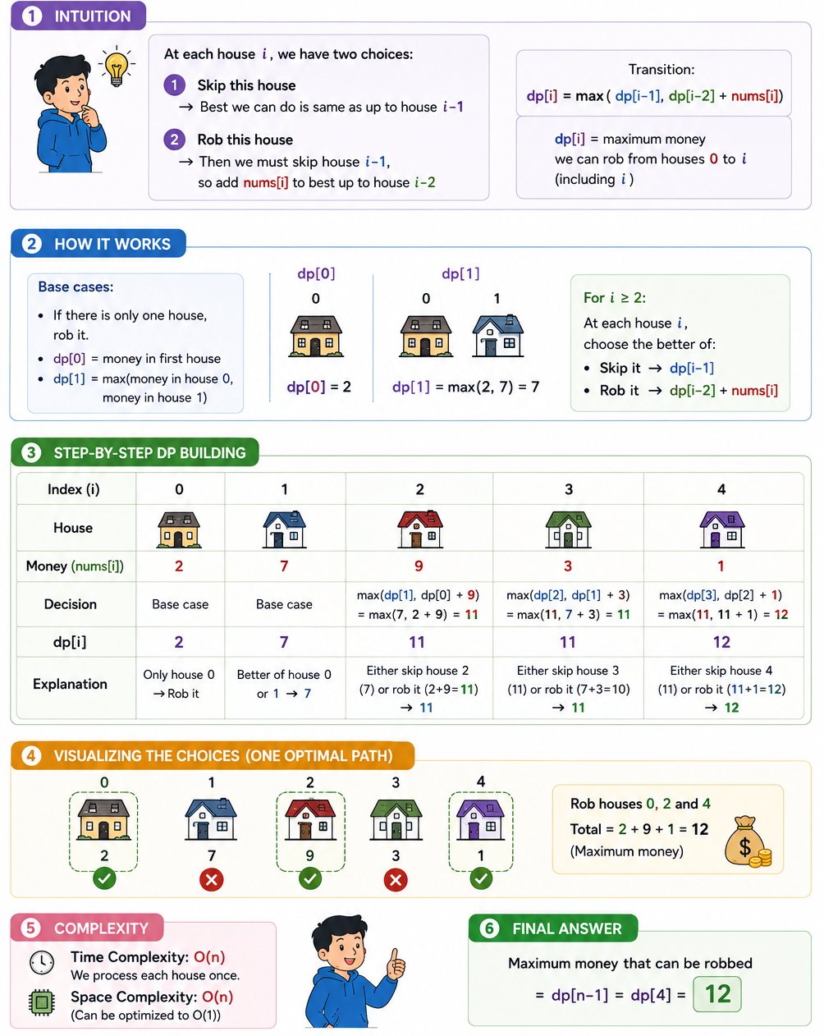3. House Robber

class Solution:
def rob(self, nums: List[int]) -> int:
n = len(nums)
dp = [0]*(n)
if n==1: return nums[0]

dp[0]=nums[0]
dp[1]= max(nums[0],nums[1])
for i in range(2,n):
dp[i] = max(dp[i-1], dp[i-2]+nums[i])

return dp[n-1]

4. House Robber 2
Just like previous question, only difference is first and last house cannot be looted together. So we will run the code to both subarrays, one without first house and one without last house and will return maximum from wither case.
Approach / Intuition: The circular constraint means house 0 and the last house can't both be robbed. So instead of solving one hard circular problem, break it into two easier linear House Robber problems:
- Exclude the last house (nums[:-1]) — allows robbing house 0 freely, since the circular link to the last house is broken by simply not considering it.
- Exclude the first house (nums[1:]) — allows robbing the last house freely, since it can no longer conflict with house 0.
Since house 0 and the last house can never both be taken, the true optimal answer must fall entirely within one of these two scenarios — so run the standard linear House Robber DP (helper) on each, and take the max of the two results.

class Solution:
def rob(self, nums: List[int]) -> int:
def helper(nums):
n=len(nums)
if n==0: return 0
if n==1: return nums[0]
dp = [-1]*n
dp[0],dp[1]=nums[0],max(nums[0],nums[1])
for i in range(2,n):
dp[i] = max(nums[i]+dp[i-2],dp[i-1])
return dp[-1]

if len(nums)==1: return nums[0]
return max(helper(nums[:-1]), helper(nums[1:]))

5. Jump Game

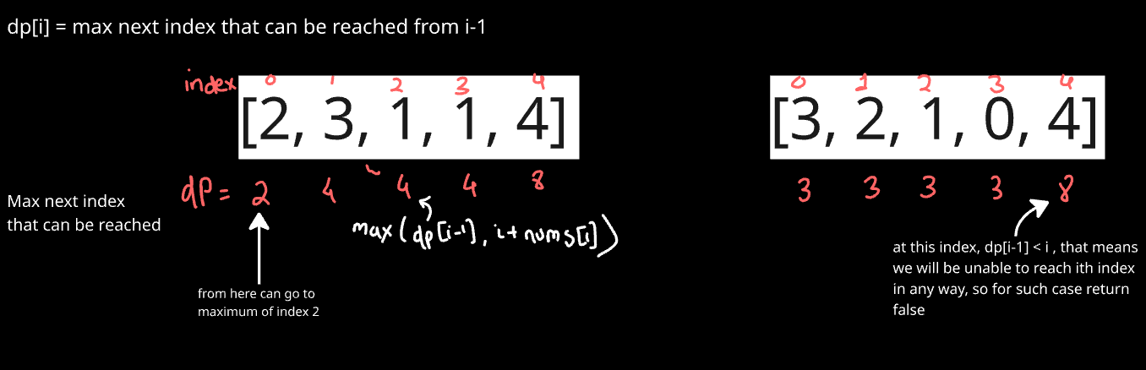

class Solution:
def canJump(self, nums: List[int]) -> bool:
n = len(nums)
dp = [0]*n
dp[0]=nums[0]

for i in range(1,n):
if dp[i-1]<i: #if at any point, we are not able to reach from previous point
return False
dp[i]=max(dp[i-1], i+nums[i]) #update furthest reach considering jump from i

return True

Approach: DP version of the same greedy idea from earlier — instead of a single running variable mj, use an array dp[i] to store the furthest index reachable using only indices 0 through i.
Intuition: dp[i] represents "the best possible reach achievable by the time you've considered up through index i." To reach index i at all, dp[i-1] (the furthest reach using positions before it) must be at least i — otherwise there's a gap you can never cross, so return False immediately. If you can reach i, then dp[i] becomes the max of your prior best reach (dp[i-1]) and the new reach if you jump from i itself (i + nums[i]) — since jumping from i is only useful if it beats what you already knew was reachable
This is more of a Greedy approach question.
#Greedy approach
class Solution:
def canJump(self, nums: List[int]) -> bool:
mj=nums[0] #max jump from any point

for i in range(1,len(nums)):
if mj<i:
return False
mj = max(mj, i+nums[i])

return True

6. Decode Ways

Intuition: To decode up to position i, the last "chunk" you decoded was either:
- A single digit (s[i-1] alone) — valid only if it's between 1 and 9 (a '0' alone has no letter mapping). If valid, all the ways to decode everything before it (dp[i-1]) still work, just with this one extra digit decoded as its own letter.
- A two-digit number (s[i-2:i]) — valid only if it's between 10 and 26 (valid letter codes). If valid, all the ways to decode everything before that (dp[i-2]) still work, with these two digits decoded together as one letter.
Since these are the only two ways the last decoded chunk could have ended at position i, and they don't overlap, dp[i] is simply the sum of whichever of these two options are valid.
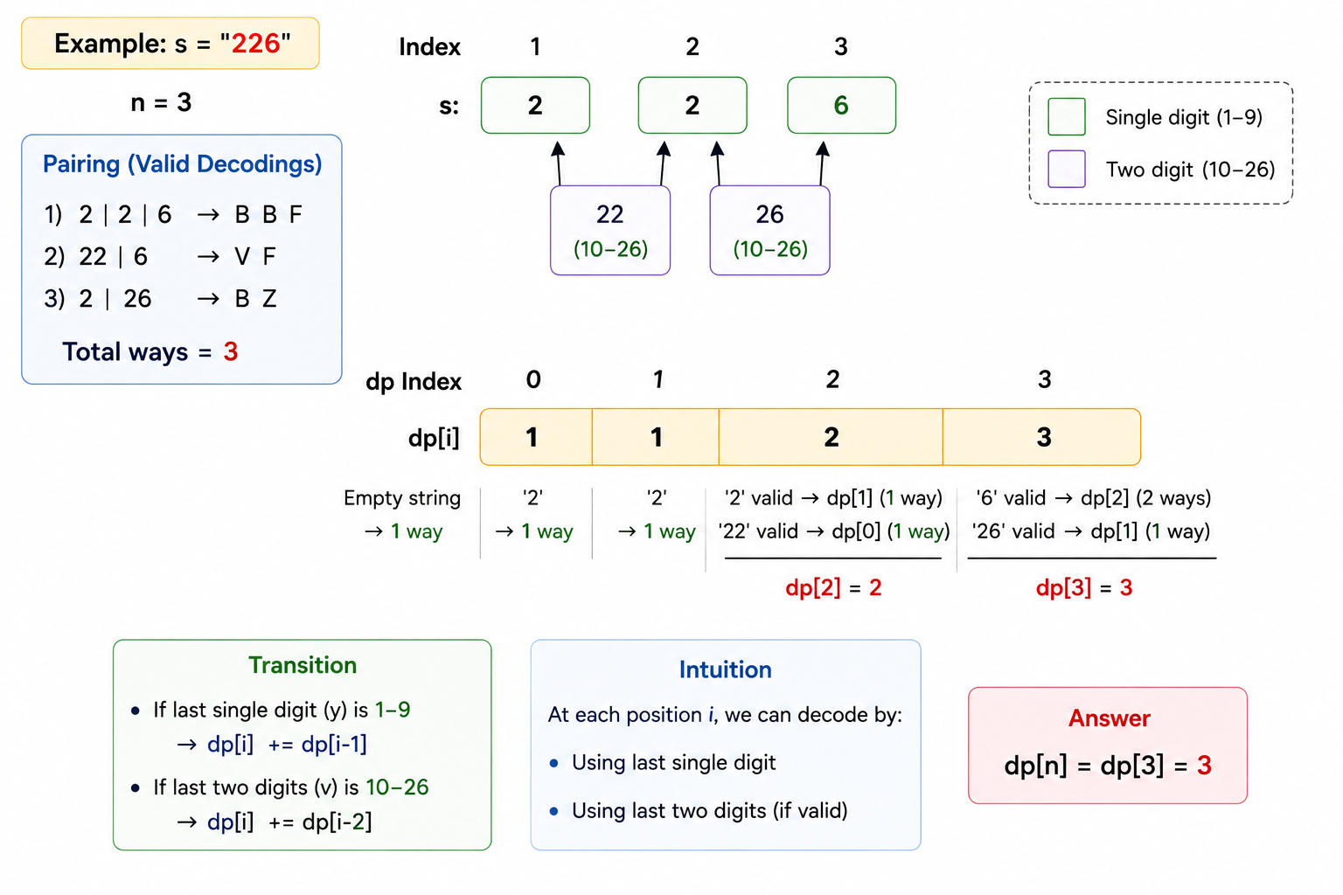

class Solution:
def numDecodings(self, s: str) -> int:
n = len(s)
dp=[0]*(n+1)

if s[0]!='0':
dp[1]=1
dp[0]=1

for i in range(2,n+1):
v = int(s[i-2]+s[i-1])
y = int(s[i-1])
if 1<=y<=9:
dp[i] += dp[i-1]
if 10<=v<=26:
dp[i] += dp[i-2]

return dp[-1]

TYPE 2: Multi-Dimensional DP

- Vacation
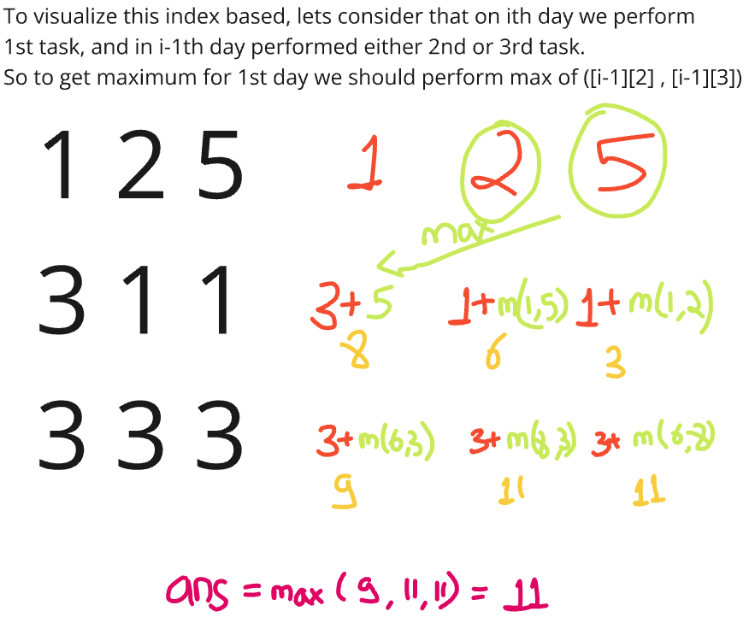
Can further do space optimization as in each step we just need to get the previous state. So in place of saving whole dp, just save the previous state.
def vacation(N, points):
dp = [[0]*3 for _ in range(N)]
dp[0][0] = points[0][0]
dp[0][1] = points[0][1]
dp[0][2] = points[0][2]

for i in range(1,N):
dp[i][0] = points[i][0] + max(dp[i-1][1],dp[i-1][2])
dp[i][1] = points[i][1] + max(dp[i-1][0],dp[i-1][2])
dp[i][2] = points[i][2] + max(dp[i-1][0],dp[i-1][1])

return max(dp[N-1])

N = int(input())
points=[]
for _ in range(N):
points.append(list(map(int,input().split())))

print(vacation(N,points))

2. Find the Maximum Length of Valid Subsequence 2

Problem in simple words: Pick some numbers from the array (keeping their order) so that every two numbers next to each other in your picked list have the same (a+b) % k value. Find the longest such list you can make.
The one clever trick to understand:
Say your current picked list ends with two numbers whose remainders are x then y (in that order). The "rule" for this list is: (x + y) % k = some fixed value, call it target.
Now if you want to add a new number with remainder z, you need:
(y + z) % k = target = (x + y) % k
If you simplify that equation, it turns out z must equal x. That's it — the next number's remainder must match the second-to-last number's remainder, not something complicated.
So instead of tracking sums, just track pairs:
dp[x][y] = "the longest list I've built so far that ends with ...x, y" (second-to-last is x, last is y).

Concept: we want (a+b)%k = (b+c)%k …. == a%k = c%k (means alternating remainders should be same)
We have 2 valid patterns:
- All elements have same remainder : r,r,r,r,r….
- Two remainders that alternate : r1, r2, r1, r2, r1, r2, r1 ……
Thus can use DP: dp[i][j] = The length of longest valid subsequence where second-to-last element had remainder i and last element had remainer j.
Number of possible remainders with k is 0->k-1.
As we iterate through nums, we’ll update this table.

class Solution:
def maximumLength(self, nums: List[int], k: int) -> int:
dp = [[0] * k for _ in range(k)]
res = 0
for num in nums:
num %= k
for prev in range(k):
dp[prev][num] = dp[num][prev] + 1
res = max(res, dp[prev][num])
return res

Explanation:
num: remainder of current number we’re adding
prev: a possible remainder for element before the current number
dp[prev][num] = dp[num][prev] + 1 means: The new length of a subsequence ending in (prev,num) is 1+ the old length of a sequence that was ending in (num,prev).
Since alternating pattern, so for remainder (r1,r2) previous should be (r2,r1)
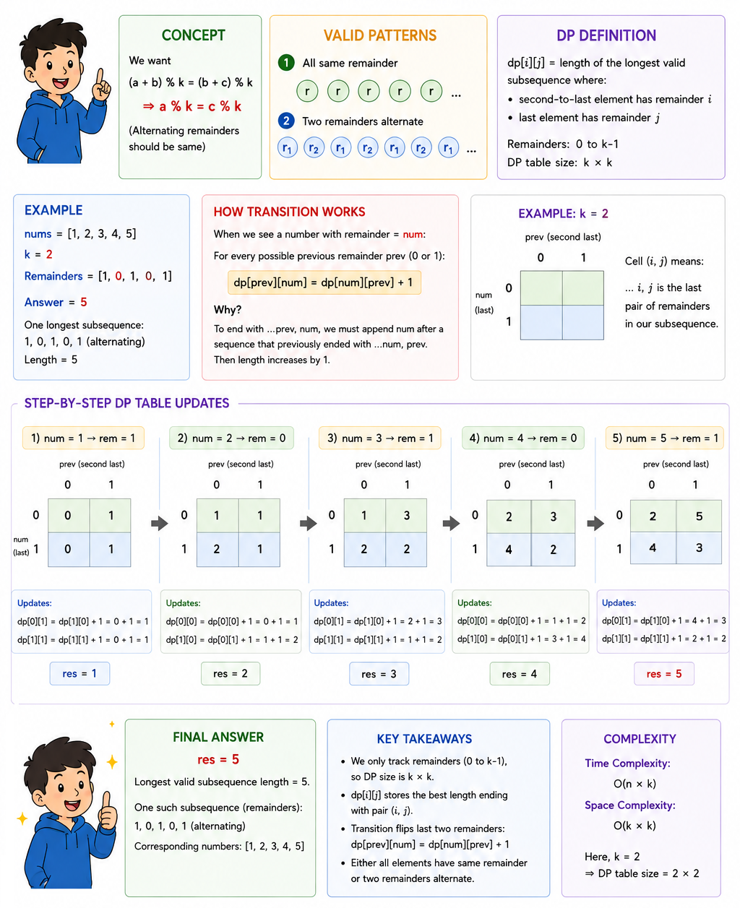

3. Stone Game
Concept: Game Theory + Interval DP (score difference trick): Rather than tracking each player's total separately, track the net score difference the current player can guarantee over their opponent, for every subrange piles[i..j]. This is a classic trick for two-player optimal games: whatever one player gains, effectively "subtracts" from the opponent, so you can express the whole game recursively as maximizing your own advantage.

class Solution:
def stoneGame(self, piles: List[int]) -> bool:
n = len(piles)

# dp[i][j] = the maximum score difference (current player's stones - opponent's stones)
# that the player whose TURN IT IS can guarantee, when only piles[i..j] remain
dp = [[0] * n for _ in range(n)]

# Base case: only one pile left (i == j) — the current player just takes it all,
# so the "advantage" is simply that pile's value (opponent gets nothing from this range)
for i in range(n):
dp[i][i] = piles[i]

# Build up solutions for increasingly larger subranges.
# length = size of the current subrange being solved
for length in range(2, n + 1): #for length one, we already have solution
for i in range(n - length + 1):
j = i + length - 1 # right end of the current subrange

# Current player has two choices:
# 1) Take the LEFT pile (piles[i]) — gain piles[i], but then the opponent
# plays optimally on the remaining [i+1, j], so subtract their best advantage
take_left = piles[i] - dp[i + 1][j] #moved left pointer by one

# 2) Take the RIGHT pile (piles[j]) — gain piles[j], but then the opponent
# plays optimally on the remaining [i, j-1], so subtract their best advantage
take_right = piles[j] - dp[i][j - 1] #moved right pointer left by one

# Current player picks whichever choice maximizes their own advantage
dp[i][j] = max(take_left, take_right)

# dp[0][n-1] = Alice's guaranteed score advantage over Bob for the WHOLE array
# (Alice moves first, so she is "the current player" for the full range)
# If this is positive, Alice ends up with more stones → she wins
return dp[0][n - 1] > 0

Why the "subtract opponent's best" trick works:
When it's your turn, you don't just want to maximize your own future pickups — you want to maximize the gap between you and your opponent. If you take a pile, your opponent then plays optimally on what's left, meaning whatever advantage they can build up effectively works against you. So your net advantage is: (pile you took) - (opponent's best advantage on the remainder). This reframing turns a two-player alternating game into a single-player maximization problem — clean and recursive. Complexity: O(n²) time, O(n²) space — filling an n x n DP table.
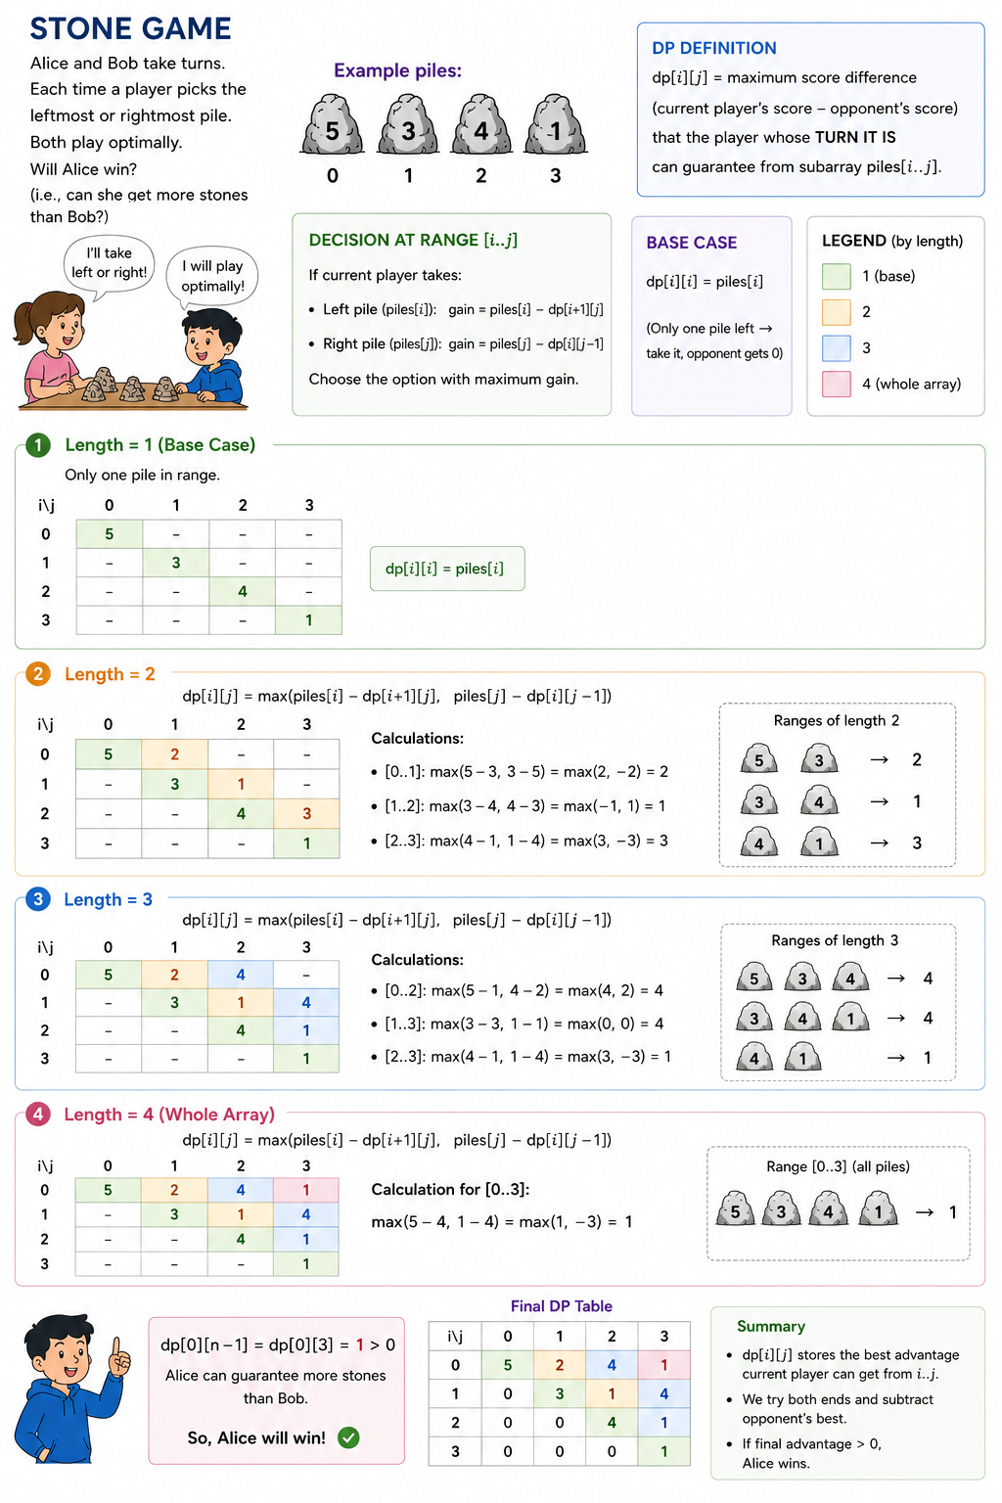

TYPE 3: DP on Grids

- Unique Paths
To go to m,n. we have 2 options. (1) go down from n-1,m (2)go right from n,m-1.
By this logic. For all m=0 or n=0 there is only one way. So value=1.

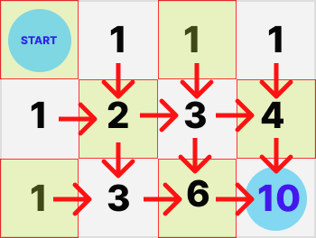

class Solution:
def uniquePaths(self, m: int, n: int) -> int:
dp = [[1] * n for i in range(m)]

for i in range(1, m):
for j in range(1, n):
dp[i][j] = dp[i - 1][j] + dp[i][j - 1]

return dp[m - 1][n - 1]

Using combination
For any given M x N grid, each unique path (no matter which one it is) requires you to move right from the starting point N - 1 times and move down from the starting point M - 1 times. Hence, regardless of the order you choose to move right or down, you need to make a total of (M - 1) + (N - 1) = M + N - 2 moves.

Then, out of the M + N - 2 moves, we need to select M - 1 moves to move right and the remaining N - 1 moves to move down. This essentially is why this problem boils down to combinatorics, because we need to calculate how many different ways we can select M - 1 moves from M + N - 2 moves (or equivalently, N - 1 moves from M + N - 2 moves).

class Solution:
def uniquePaths(self, m: int, n: int) -> int:
return math.comb(m+n-2, m-1) # or math.comb(m+n-2, n-1)

2. Unique Paths 2
Approach: Bottom-up DP where dp[i][j] = number of distinct paths to reach cell (i,j) from the top-left, moving only down or right. If a cell is an obstacle, no paths can pass through it, so dp[i][j] = 0. Otherwise, the number of ways to reach (i,j) is the sum of ways to reach it from above (dp[i-1][j]) and from the left (dp[i][j-1]) — since those are the only two possible entry directions. Edge cells missing a predecessor (first row/column) treat that direction as 0. dp[0][0] = 1 seeds the start (one trivial way to "be" at the starting cell, unless it's itself an obstacle — which the loop correctly zeroes out on its first iteration). The answer is dp[m-1][n-1], total paths to the bottom-right corner.
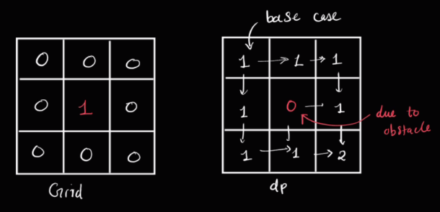

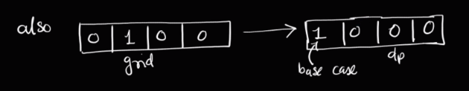

class Solution:
def uniquePathsWithObstacles(self, obstacleGrid: List[List[int]]) -> int:
m,n = len(obstacleGrid), len(obstacleGrid[0])
dp = [[0]*n for _ in range(m)]
dp[0][0]=1

for i in range(m):
for j in range(n):
if obstacleGrid[i][j]==1:
dp[i][j]=0
else:
u = dp[i-1][j] if i>0 else 0
l = dp[i][j-1] if j>0 else 0
dp[i][j]+= u+l

return dp[m-1][n-1]

3. Minimum Path Sum
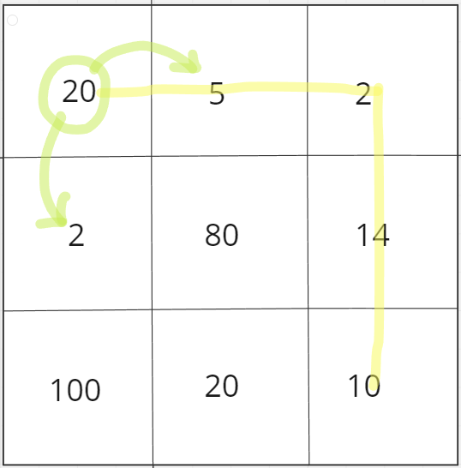
If we use greedy strategy here. Then we must be going to 2, instead of 5. But 5 gives us best results globally. So for this case as we have global consideration to get best results, we use dp to check all possible paths and get best results.
Approach: Bottom-up DP where dp[i][j] = minimum cost to reach cell (i,j) from the top-left corner. Since you can only move down or right, the cheapest way to reach (i,j) is its own cost plus whichever of its two possible predecessors — from above (dp[i-1][j]) or from the left (dp[i][j-1]) — was cheaper. Edge cells missing a predecessor (first row/column) treat that direction as infinity so it's never chosen. The answer is dp[n-1][m-1], the minimum cost path to the bottom-right corner.
Note: dp = grid.copy() only does a shallow copy — since grid is a list of lists, dp and grid share the same inner row lists, so mutating dp[i][j] += ... also mutates the original grid as a side effect. Works fine here since grid isn't needed afterward, but worth knowing (copy.deepcopy(grid) would avoid this if it mattered).

class Solution:
def minPathSum(self, grid: List[List[int]]) -> int:
n,m = len(grid), len(grid[0])
dp = grid.copy()

for i in range(n):
for j in range(m):
if i==0 and j==0: continue
up = dp[i-1][j] if i>0 else float('inf')
left = dp[i][j-1] if j>0 else float('inf')
dp[i][j] += min(up,left)

return dp[n-1][m-1]

4. Maximal Square
Intuition: dp[i][j] = side length of the largest all-1s square whose bottom-right corner is at (i,j). A square of size k can only exist at (i,j) if there's already a square of size at least k-1 immediately above, to the left, and diagonally above-left — so the limiting factor is always the smallest of those three, plus one for the current cell itself.
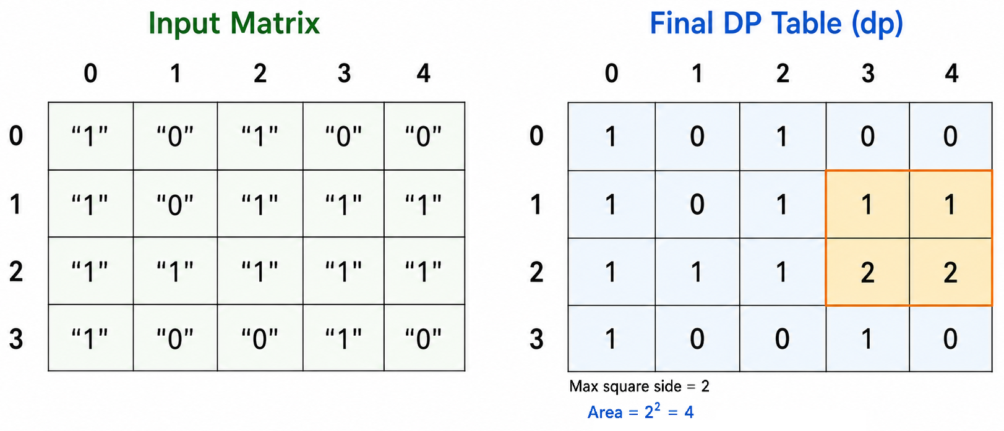

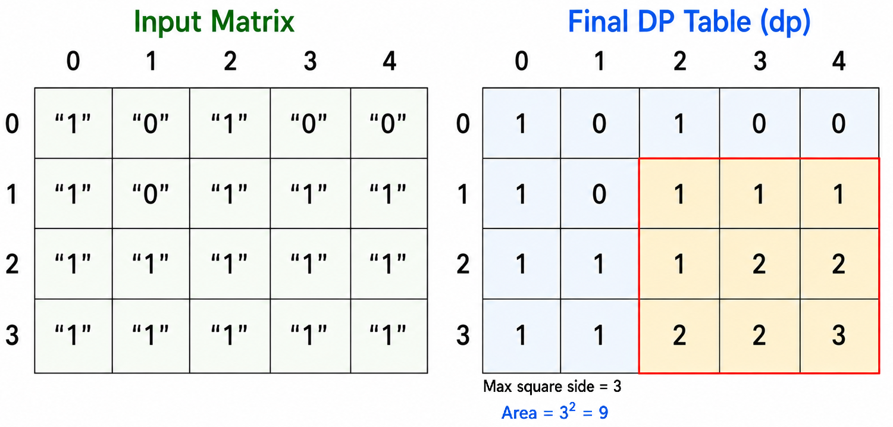

class Solution:
def maximalSquare(self, matrix: List[List[str]]) -> int:
n, m = len(matrix), len(matrix[0])
dp = [[0] * m for _ in range(n)]
max_side = 0

for i in range(n):
for j in range(m):
if matrix[i][j] == "1":
if i == 0 or j == 0:
# first row/column: a '1' can only form a 1x1 square here,
# since there's no room to expand up/left
dp[i][j] = 1
else:
# the largest square ending at (i,j) is limited by the
# SMALLEST of its three neighbors — top, left, top-left —
# since a bigger square needs all three sides to support it
dp[i][j] = 1 + min(dp[i-1][j], dp[i][j-1], dp[i-1][j-1])
max_side = max(max_side, dp[i][j])

return max_side * max_side

TYPE 4: Knapsack

- Knapsack-1
Intuition: For each item i, you only have two choices:
- Don't pick it — your best value is whatever's achievable using items 0..i-1 with the same capacity (rec(i-1, Tw)).
- Pick it (only if it fits, wt[i] <= Tw) — you gain val[i], but now have less capacity left, so add the best achievable using items 0..i-1 with Tw - wt[i] capacity.
Take whichever choice gives more value. Since the array can only be split at item i in these two ways (each item is binary: pick or skip), this exhaustively covers every combination without brute-forcing all 2^n subsets — memoization prevents recomputation of the same (i, Tw) state.
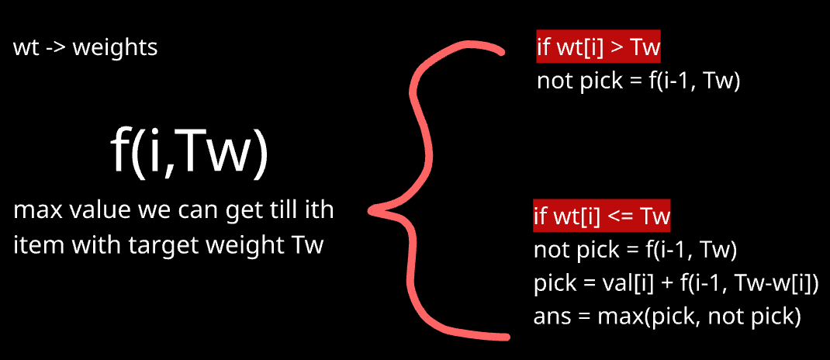
class Solution:
def knapsack(self, W: int, val: list[int], wt: list[int]) -> int:

def rec(i, Tw, dp):
# Base case: only item 0 left to consider.
# Take it if it fits, otherwise nothing to add.
if i == 0:
if wt[0] <= Tw:
return val[0]
return 0

if dp[i][Tw] != -1: #applying dp
return dp[i][Tw]

not_pick = rec(i-1, Tw, dp)
pick = 0
if wt[i] <= Tw:
# gain val[i], reduce capacity, solve remaining items 0..i-1
pick = val[i] + rec(i-1, Tw-wt[i], dp)

# Store and return the best of the two choices
dp[i][Tw] = max(pick, not_pick)
return dp[i][Tw]

n = len(val)
# dp[i][Tw] = max value achievable using items 0..i with capacity Tw
dp = [[-1]*(W+1) for _ in range(n)]
return rec(n-1, W, dp)

Bottom up
Approach: Build a 2D table dp[i][j] = maximum value achievable using the first i items, with capacity j. Fill it iteratively from smaller subproblems up to the full problem, instead of recursing top-down.
Intuition: Same core logic as the recursive version — for each item, you either skip it or take it (if it fits) — but now expressed as a forward-filling table where dp[i][j] is built directly from previously computed rows, rather than computed on-demand via recursive calls.
Note: Can’t do in 1D DP, as eg lets say object of weight 3 is present, Now for dp[6], dp[6]= take object of weight 3 + dp[6-3] . So in this case 3 is considered twice. So here use 2D dp, which make sure every object is considered only once. (This are called 0/1 Knapsack)
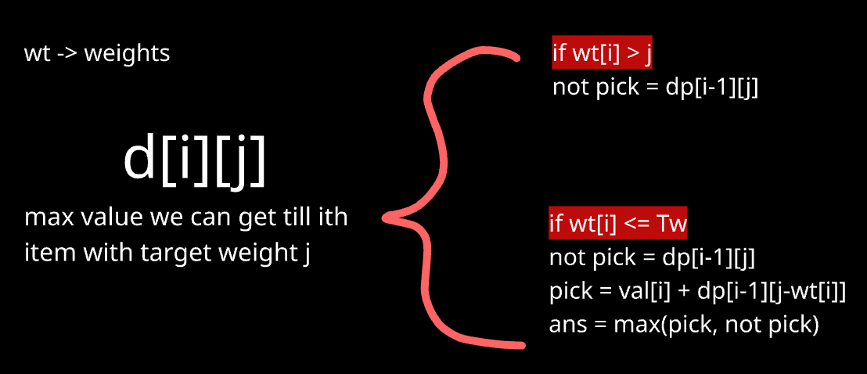

class Solution:
def knapsack(self, W: int, val: list[int], wt: list[int]) -> int:
n = len(val)

# dp[i][j] = max value achievable using the first i items, with capacity j
# +1 row/col to cleanly represent "0 items" and "0 capacity" as base cases (all 0)
dp = [[0]*(W+1) for _ in range(n+1)]

# i represents "considering first i items" (1-indexed, so wt[i-1]/val[i-1] is the actual item)
for i in range(1, n+1):
for j in range(1, W+1):

if wt[i-1] <= j:
dp[i][j] = max(dp[i-1][j], val[i-1] + dp[i-1][j-wt[i-1]])
else:
dp[i][j] = dp[i-1][j] # Item i-1 doesn't fit — forced to skip it

# best value using all n items, with full capacity W
return dp[n][W]

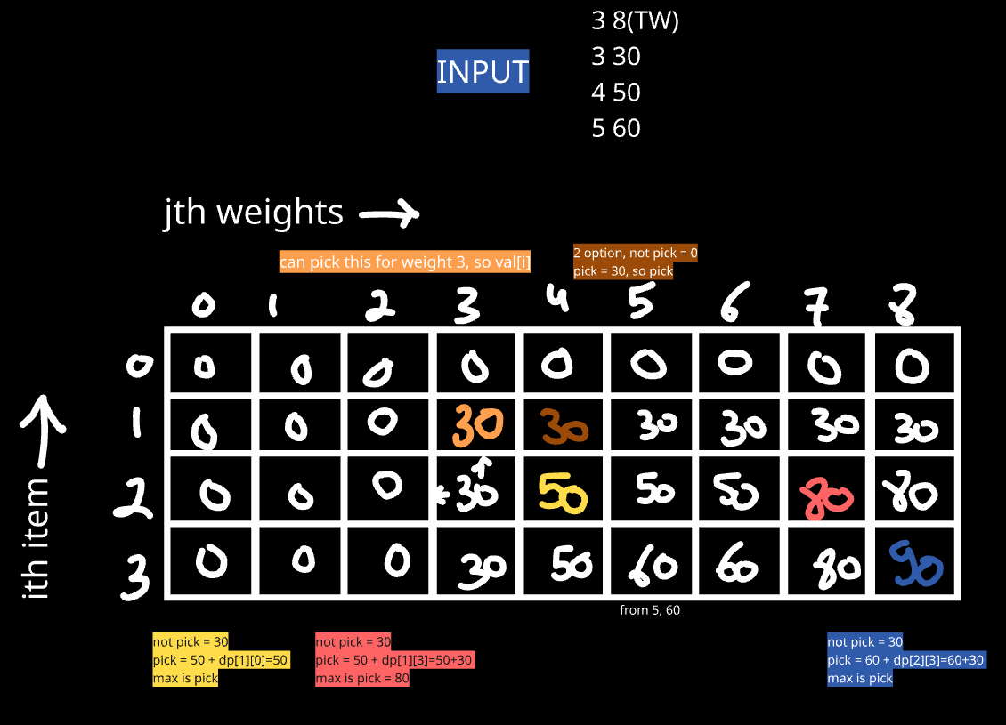
Here using this approach, as one weight can be picked only once.

- Coin Change
Approach 1 : Just like previous one, but there since same value can’t be pick twice, so in pick case we were doing dp[i-1], but here same I can be picked again, so in pick condition don’t change to i-1 and check again for ith (This are called unbounded Knapsack)
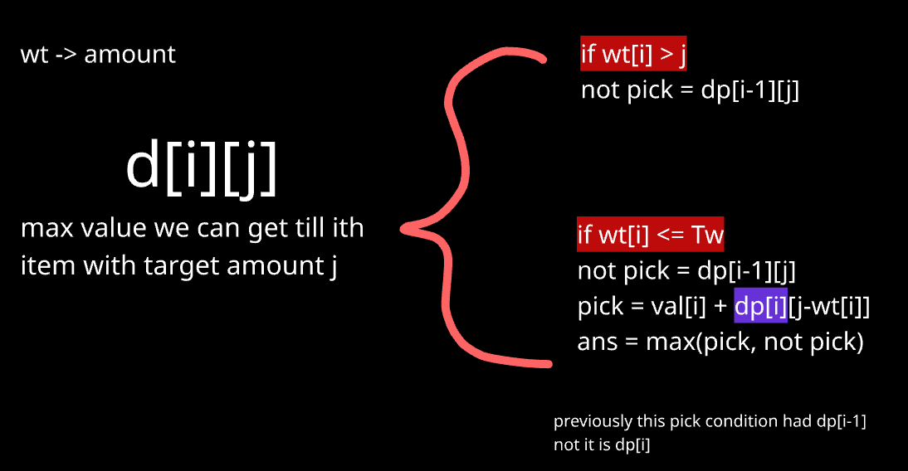
For base condition
Since we iterate row wise, we have to fill 0th row for base condition. now if we have target and only coins[0] as coin, so maximum coins we can put is target//coins[0]. So will do that.
class Solution:

def coinChange(self, coins: List[int], amount: int) -> int:
n = len(coins)
dp = [[0]*(amount+1) for _ in range(n)]

for t in range(amount+1):
if t%coins[0]==0 :
dp[0][t] = t//coins[0]
else:
dp[0][t] = float('inf')

#moving row wise
for i in range(1,n):
for j in range(amount+1):
not_pick = dp[i-1][j]
pick = float('inf')
if coins[i] <= j:
pick = 1 + dp[i][j-coins[i]]
dp[i][j] = min(pick,not_pick)

return dp[n-1][amount] if dp[n-1][amount]!=float('inf') else -1

Approach 2: Just loop from 0 to amount, and for each value, check which coin from coins give minimum ans and put that in dp
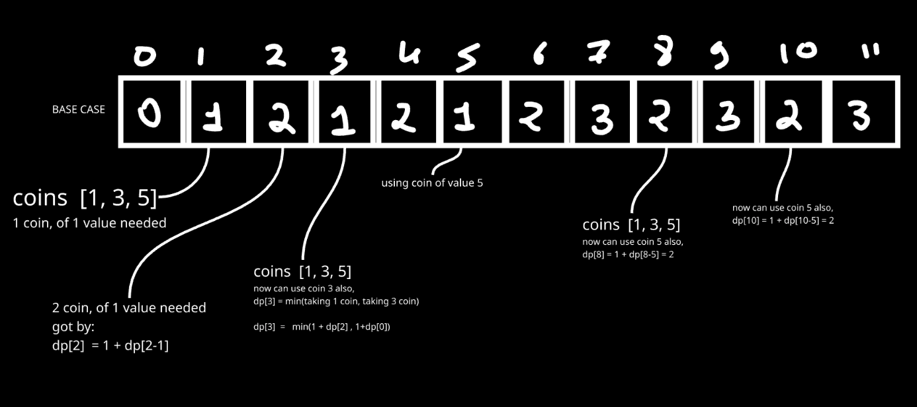
#Bottom up (performs better both space and time wise)
class Solution:
def coinChange(self, coins: List[int], amount: int) -> int:
dp = [float('inf')]*(amount+1)
dp[0]=0
for i in range(1,amount+1):
for j in coins:
if j<=i:
dp[i] = min(dp[i], 1+dp[i-j])
return dp[amount] if dp[amount]!=float('inf') else -1

class Solution: #Top down
def coinChange(self, coins: List[int], amount: int) -> int:
def helper_td(n , coins , dp):
if n==0: return 0
if dp[n]!=-1:return dp[n]

temp = float('inf')
for i in coins:
if i <= n:
temp = min(temp,1+helper_td(n-i,coins,dp))
dp[n] = temp
return dp[n]

dp = [-1]*(amount+1)
ans=helper_td(amount , coins, dp)

- Coin Change II
class Solution:
def change(self, amount: int, coins: List[int]) -> int:
n = len(coins)
# dp[i][j] = number of ways to make amount j using the first i coin types
dp = [[0]*(amount+1) for _ in range(n+1)]

# Base case: amount 0 has exactly 1 way to be made — using no coins at all,
for i in range(n+1):
dp[i][0] = 1

for i in range(1, n+1):
for j in range(1, amount+1):
if coins[i-1] <= j:
dp[i][j] = dp[i-1][j] + dp[i][j-coins[i-1]]
else:
dp[i][j] = dp[i-1][j] #current coin is too big to use — skip it
return dp[n][amount]

Approach: Bottom-up DP, tabulation. Define dp[i][j] = number of ways to make amount j using only the first i coin types (each usable any number of times).
Key intuition — why dp[i][j-coins[i-1]] uses row i, not i-1: This is the detail that makes Coin Change II different from 0/1 Knapsack. In knapsack, each item can only be used once, so after using an item you must move to the previous row (i-1) to avoid reusing it. Here, coins are unlimited — after using one coin of type coins[i-1], you're still allowed to use another coin of the same type. So you stay on the same row i, just with a smaller remaining amount (j - coins[i-1]). This is exactly what allows unlimited reuse of the same coin type within the DP.

Why 1D dp like coin change work here:
When you try to use 1D DP: For n=3, it gives 3 since: 1,1,1 1,2 and 2,1 for 3 (but 2 are similar). But It should have been 2.
Reason: In coin change, you're asking: "What's the minimum number of coins to make amount j?" It genuinely doesn't matter what order the coins were used in, or which specific combination was used — you only care about the best (smallest) count. So order never leaks In answer.
In coin change 2: you're asking: "How many distinct combinations of coins sum to j?" Now the path/order actually matters to how you're building the count — even though the final answer shouldn't care about order, the way you're accumulating the count does

- Subset Sum
Approach 1: Using plain recursion and doing pick and non-pick. But this will give TLE
class Solution:
def isSubsetSum (self, arr, sum):
# code here
def checkSubs(sub_sum,i):
if i==len(arr):
if sub_sum==sum:
return True
return False
else:
pick = checkSubs(sub_sum+arr[i],i+1)
not_pick = checkSubs(sub_sum,i+1)
return pick or not_pick

return checkSubs(0,0)

Approach 2: Using Knapsack pattern. This is equivalent to 1st knapsack problem. Our sack can handle weight (sum) and we are given list of weights. Here value is not given as we just need to say true or false.
Bottom-up DP (tabulation). Define dp[i][j] = "is it possible to make sum j using some subset of the first i elements?" — a boolean instead of a count, since we only care about existence, not how many ways.
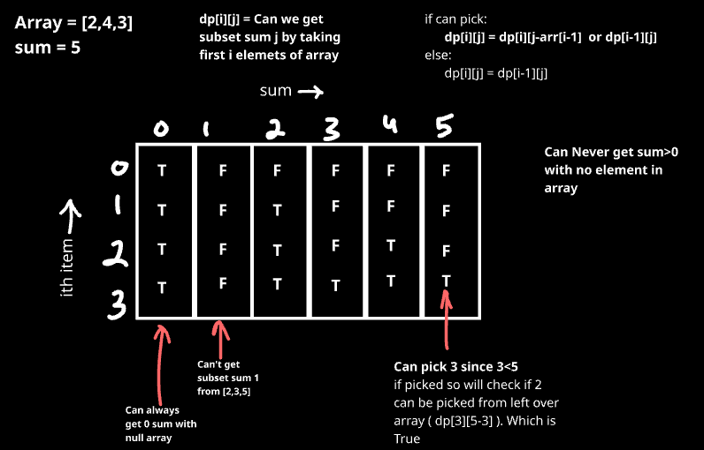
Intuition: This is the boolean cousin of the 0/1 Knapsack pattern. For each element, you have exactly two choices — in For each element arr[i-1] and target j:
- If it fits (arr[i-1] <= j): sum j is achievable using the first i elements if either:
  - You pick arr[i-1] — then you need the remaining elements (i-1 of them) to make up the leftover sum (j - arr[i-1]): dp[i-1][j-arr[i-1]]
  - You skip arr[i-1] — then you need sum j achievable using just the first i-1 elements: dp[i-1][j]
Since you only need one path to work (it's a yes/no question), use or instead of max/sum.
- If it doesn't fit (arr[i-1] > j): you're forced to skip it — sum j is achievable iff it was already achievable using the first i-1 elements: dp[i][j] = dp[i-1][j].
class Solution:
def isSubsetSum (self, arr, sum):
n = len(arr)
dp = [[False]*(sum+1) for _ in range(n+1)]

for i in range(n+1): #if required sum=0, its always possible
dp[i][0]=True

for i in range(1,n+1):
for j in range(1, sum+1):
if arr[i-1] <= j: #so can pick (pick or non-pick)
dp[i][j] = dp[i-1][j-arr[i-1]] or dp[i-1][j]
else: #if can't pick. ans = whatever we got till i-1 array
dp[i][j] = dp[i-1][j]

return dp[n][sum]

5. Partition Equal Subset Sum
Approach: It is equivalent to previous problem. Here if sum of array is s, we need to find subarray with sum s/2. If this is possible, by default other subarray will also have sum=s/2

class Solution:
def canPartition(self, nums: List[int]) -> bool:
s = sum(nums)
if s%2!=0: #if sum is even (then only it can split into 2)
return False

#if we get one subarray of sum s/2, by default other one will have sum s/2
#same as finding subarray with given sum
rs = s//2
n = len(nums)
dp = [[False]*(rs+1) for _ in range(n+1)]

#for 0 sum all is True
for i in range(n+1):
dp[i][0]=True

for i in range(1,n+1):
for j in range(1, rs+1):
if nums[i-1] <= j: #so can pick
dp[i][j] = dp[i-1][j-nums[i-1]] or dp[i-1][j]
else: #if can't pick. ans = whatever we got till i-1 array
dp[i][j] = dp[i-1][j]

return dp[n][rs]

6. Partitions with given difference
This problem can be asked in 3 variants:
1. Number of subsets with given sum: in that we will just need to count subset sums=k. So it will include 2nd half of solution we added below
Link: https://www.geeksforgeeks.org/problems/perfect-sum-problem5633/1
2. Second is this one for which we added our code below
3. Target sum: Here we have to add +/- to have given target. After adding + for few and - for other we will have sum(a,d,e) – sum(b,c)= target. So this is exactly equal to the code added below.
Link: https://leetcode.com/problems/target-sum/description/

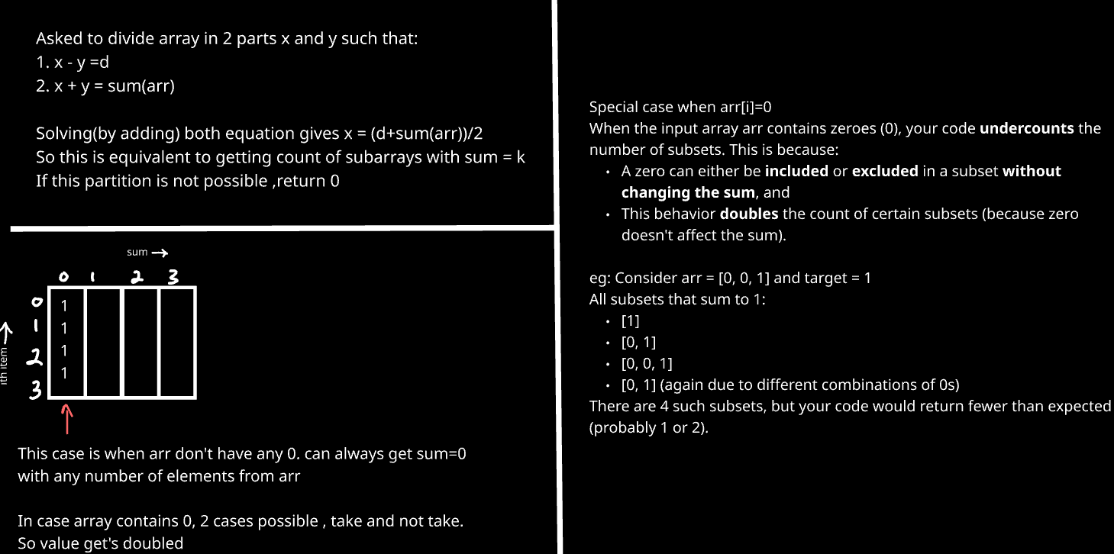

class Solution:
def countPartitions(self, arr, d):
n = len(arr)
MOD = 10**9 + 7
total = sum(arr)

# If partition not possible
if (total + d) % 2 != 0 or d > total:
return 0

s = (total + d) // 2

# DP: count subsets with sum = s
dp = [[0] * (s + 1) for _ in range(n + 1)]
dp[0][0] = 1

for i in range(1, n + 1): # Handling case for 0’s
if arr[i - 1] == 0:
dp[i][0] = dp[i - 1][0] * 2
else:
dp[i][0] = dp[i - 1][0]

for i in range(1, n + 1):
for j in range(s + 1):
if arr[i - 1] <= j: # pick + not pick (add number of ways from both)
dp[i][j] = (dp[i - 1][j - arr[i - 1]] + dp[i - 1][j]) % MOD
else: # Not pick (so number of ways for dp[0…i]=dp[0…i-1]
dp[i][j] = dp[i - 1][j]
return dp[n][s]

7. Last Stone Weight II
It is equivalent to: Partition array in 2 subsets whose difference of sum is minimum (array has positive values).
Below code fails when array have negative nums.

The core problem: Partition nums into two subsets, minimizing the absolute difference between their sums.

So if subsets sum are s1 and s2:
s1 + s2 = s (sum of nums)
s1 – s2 = x (we have to minimise x)
Comes up: 2*s1 – s = x. So now we need to minimise 2*s1 – s (absolute value)
So when s1 = s/2, it is minimum. If not, check s/2-1, s/2-2 ….. which ever possible.
So use code of partition equal subset sum and then check from dp[n][s//2] ------> dp[n][0]. Whichever is possible

class Solution:
def lastStoneWeightII(self, nums: List[int]) -> int:
s = sum(nums)

#same partition equal subset sum code
rs = s//2
n = len(nums)
dp = [[False]*(rs+1) for _ in range(n+1)]

#for 0 sum all is True
for i in range(n+1):
dp[i][0]=True

for i in range(1,n+1):
for j in range(1, rs+1):
if nums[i-1] <= j: #so can pick
dp[i][j] = dp[i-1][j-nums[i-1]] or dp[i-1][j]
else: #if can't pick. ans = whatever we got till i-1 array
dp[i][j] = dp[i-1][j]

# Now search from rs DOWN to 0, and return as soon as we hit the FIRST
# (i.e. largest) achievable sum. Since we want total as CLOSE to s/2 as possible,
# the largest achievable sum <= s/2 gives the minimum difference.
for total in range(rs,0,-1):
if dp[n][total]: #given sum for s1 is possible. return s-2*total
return s-2*total

return s #when only one elemenet is present in nums

Why searching from rs downward, and stopping at the first hit, is correct:
We want the subset sum total that's closest to rs = s/2 without exceeding it (a value larger than rs would just be the complement of a smaller valid sum — searching up to rs alone already covers every meaningful partition, since sums above s/2 just mirror ones below it). By scanning total from rs down to 1 and returning on the first True found, we guarantee we've found the largest achievable sum ≤ rs, which directly minimizes s - 2*total (the difference formula).

TYPE 5: Kadane’s Algorithm

1. Maximum Subarray

class Solution:
def maxSubArray(self, nums: List[int]) -> int:
curr=0
maxSum=nums[0]

for num in nums:
if curr<0: #when sum becomes negative, start from 0
curr = 0
curr+=num
maxSum = max(maxSum,curr)

return maxSum

At each position i, we have two choices:
- Extend the previous subarray: max_ending_here + arr[i]
- Start a new subarray from current element: arr[i]

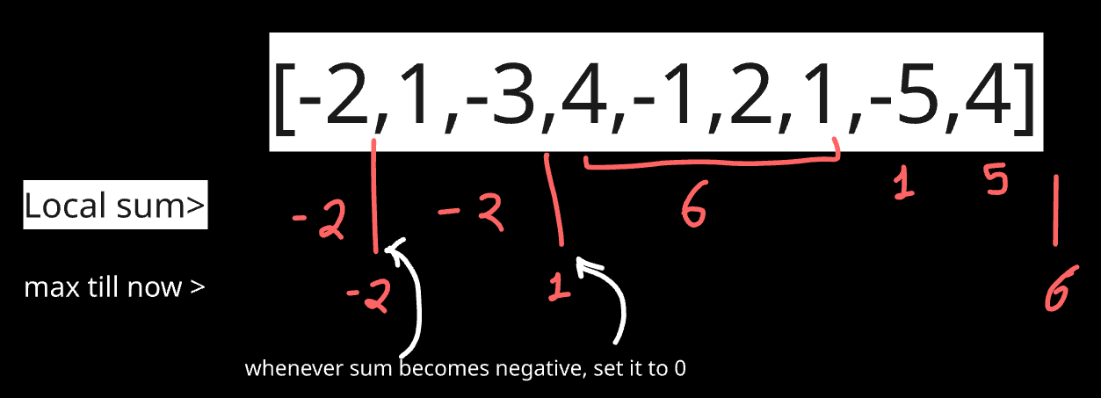

Why is Kadane’s Algorithm Dynamic Programming?
Because it builds the solution using:
- Optimal substructure: Solution at index i depends on solution at i-1.
- Overlapping sub problems: Repeated computation of subarray sums.
- But it uses space optimization (constant space), which is why it may not seem like "typical" DP.

- Best time to buy and sell stock
To get maximum profit on i^{th} day, you have to buy that at minimum price till 1->i-1th day. So we will keep track of minimum value.

class Solution:
def maxProfit(self, prices: List[int]) -> int:
min_price = prices[0]
profit=0

for price in prices[1:]:
profit = max(profit, price-min_price)
min_price = min(min_price, price)

return profit

- Best time to buy and sell stock II
Here we can buy and sell multiple times, so better is that buy every time possible if next one is having more price.
Check from graph, whenever there is rise.
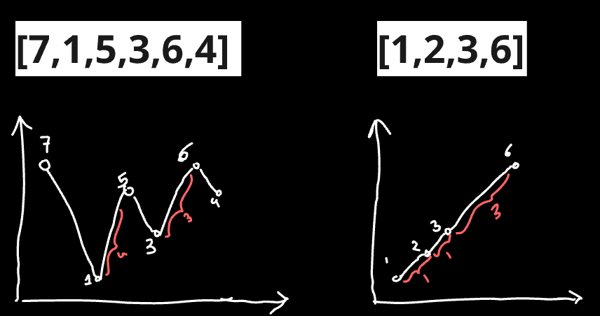

class Solution:
def maxProfit(self, prices: List[int]) -> int:
profit=0
for i in range(1,len(prices)):
if prices[i]-prices[i-1]>0:
profit += prices[i]-prices[i-1]

return profit

TYPE 6: String DP

1. Longest common subsequence
Here recursive relation is:
Eg:- st1= “abc” , st2=“adb” , I know st1[0] == st2[0],
So to get lcs, do lcs(“abc”, “adb”) = 1 + lcs(“bc”,”db”)

Eg2:- st1= “pqrs” , st2= “xqor” , I know st1[0] != st2[0]
So to get lcs, do lcs(“pqrs”, “xqor”) = max( lcs(“qrs” , “xqor”) , lcs(“pqrs”, “qor”) )
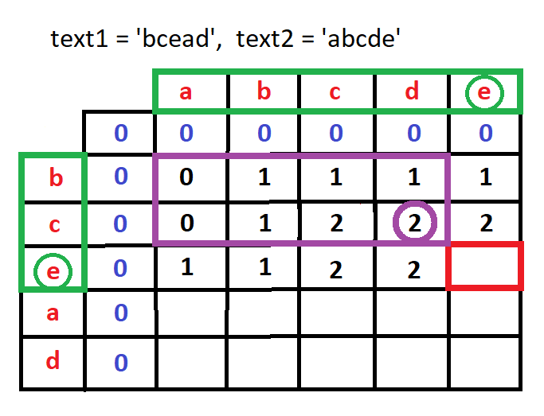
For this red box:
Till now, text1=”bce” and text2=”abcde”
Now since last values are equal, it is equal to 1+lcs(“bc”, “abcd”) =3

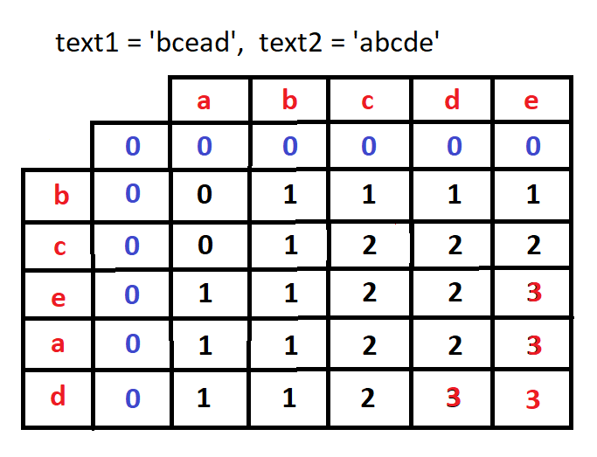

class Solution:
def longestCommonSubsequence(self, text1: str, text2: str) -> int:
n,m=len(text1),len(text2)
dp = [[0]*(m+1) for i in range(n+1)] #m+1 rows and n+1 columns

for i in range(1,n+1):
for j in range(1,m+1):
if text1[i-1]==text2[j-1]:
dp[i][j] = 1+dp[i-1][j-1]
else:
dp[i][j] = max(dp[i-1][j] ,dp[i][j-1])
return dp[n][m]

## Demo run
'' a c e
'' [0, 0, 0, 0]
a [0, 1, 1, 1]
b [0, 1, 1, 1]
c [0, 1, 2, 2]
d [0, 1, 2, 2]
e [0, 1, 2, 3]

For top down: Will start looking from last values str[-1] and str[-2]

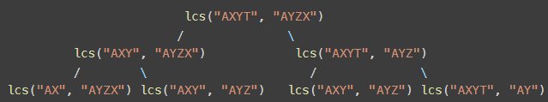
#Normal Recursion
class Solution:
def longestCommonSubsequence(self, text1: str, text2: str) -> int:
n = len(text1)
m = len(text2)
def helper(i, j):
if i==0 or j==0: return 0
if text1[i-1] == text2[j-1]:
return helper(i-1,j-1)+1
else:
return max(helper(i-1, j), helper(i, j-1))

return helper(n,m)

#Recursion + memorization = DP
class Solution:
def longestCommonSubsequence(self, text1: str, text2: str) -> int:
n, m = len(text1), len(text2)
dp = [[-1]*(m+1) for _ in range(n+1)]

def helper(i,j):
if i==0 or j==0:
return 0
if dp[i][j]!=-1:
return dp[i][j]
if text1[i-1]==text2[j-1]:
dp[i][j] = 1+helper(i-1,j-1)
else:
dp[i][j] = max(helper(i-1,j),helper(i,j-1))
return dp[i][j]

return helper(n,m)

3. Print Longest Common Subsequence
Here will keep code same as LCS, now length of LCS will be at dp[n][m], from that place we will iterate back to top checking from where the value really got increased. If s1[i-1] = s2[j-1] , then it will be part of ans, else check up and left, from where value got increased and iterate till top.

def lcs(s1, s2):
n , m = len(s1) , len(s2)
dp = [[0]*(m+1) for _ in range(n+1)]

for i in range(1, n+1):
for j in range(1, m+1):
if s1[i-1] == s2[j-1]:
dp[i][j] = 1 + dp[i-1][j-1]
else:
dp[i][j] = max(dp[i-1][j], dp[i][j-1])

#now maximum value is present at dp[n][m]
#will iterate form n,m to 0,0 and check at what places value of dp[i][j] increased

i, j = n, m
ans=''
while(i>0 and j>0):
if s1[i-1] == s2[j-1]:
ans += s1[i-1]
i-=1
j-=1
elif dp[i-1][j]>dp[i][j-1]:
i-=1
else:
j-=1

return ans[::-1] # since iterated from bottom to top, got ans in reversed order

s1 = input()
s2 = input()
print(lcs(s1, s2))

4. Longest Common Substring
A subsequence is a sequence derived from another sequence by deleting some or no elements without changing the order of the remaining elements.
While a substring must be continues.

For substring, we just need few modifications in LCS:
- If s1[i] != s2[j], at this point substring chain is broken, so make dp[i][j] as 0
- Largest substring can be present at any point, even in mid of 2 substring. So ans is not just present on dp[n][m]. But it is max value present in whole dp. So keep track of that.

class Solution:
def longestCommonSubstr(self, s1, s2):
# code here
n,m = len(s1), len(s2)
dp = [[0]*(m+1) for _ in range(n+1)]

mx=0
for i in range(1,n+1):
for j in range(1,m+1):
if s1[i-1]==s2[j-1]:
dp[i][j] = 1+dp[i-1][j-1]
mx = max(mx,dp[i][j])
else:
dp[i][j]=0

return mx

5. Minimum number of deletions and insertions
For heap to become pea
Heap ea pea
Basically s1 ----deleletion-----> LCS ------insertion---->s2

No of deletion: len(s1)-len(lcs)
No of insertion: len(s2)-len(lcs)
class Solution:
def minOperations(self, s1, s2):
# code here
n,m = len(s1),len(s2)
dp = [[-1]*(m+1) for _ in range(n+1)]

def rec(n,m,dp):
if n==0 or m==0:
return 0
if dp[n][m]!=-1:
return dp[n][m]
if s1[n-1]==s2[m-1]:
dp[n][m] = 1+ rec(n-1,m-1,dp)
else:
dp[n][m] = max(rec(n-1,m,dp), rec(n,m-1,dp))
return dp[n][m]

lcs = rec(n,m,dp)
ans = (n-lcs) + (m-lcs)
return ans

6. Longest Palindromic Subsequence

#can be considered equivalent to finding LCS of string with it's reverse
class Solution:
def longestPalindromeSubseq(self, s: str) -> int:

def helper(i,j):
if i==0 or j==0:
return 0
if dp[i][j]!=-1:
return dp[i][j]
if s1[i-1]==s2[j-1]:
dp[i][j] = 1 + helper(i-1,j-1)
else:
dp[i][j] = max(helper(i-1,j) , helper(i,j-1))
return dp[i][j]

s1 = s
s2 = s[::-1] #reverse of original string
n = len(s)
dp = [[-1]*(n+1) for _ in range(n+1)]

helper(n,n)
return dp[n][n]

7. Minimum Insertion Steps to Make a String Palindrome
First we will get the length of longest palindrome possible from given string. This can be done by finding LCS between string and it’s reverse.
Eg: for aebchba: longest palindrom is abcba or abhba
We are left with e,h or e,c, so if asked how many deletion or insertion(in this question) required to make string palindrome, it will be 2.
After 2 insertion it becomes: aebchcbea or aebhchbea

class Solution:
def minInsertions(self, s: str) -> int:
s1 = s
s2 = s[::-1]
n = len(s)
dp = [[0]*(n+1) for _ in range(n+1)]
for i in range(1,n+1):
for j in range(1,n+1):
if s1[i-1]==s2[j-1]:
dp[i][j] = 1+dp[i-1][j-1]
else:
dp[i][j] = max(dp[i][j-1], dp[i-1][j])

lcs_length = dp[n][n]
return n-lcs_length

8. Shortest Common Supersequence
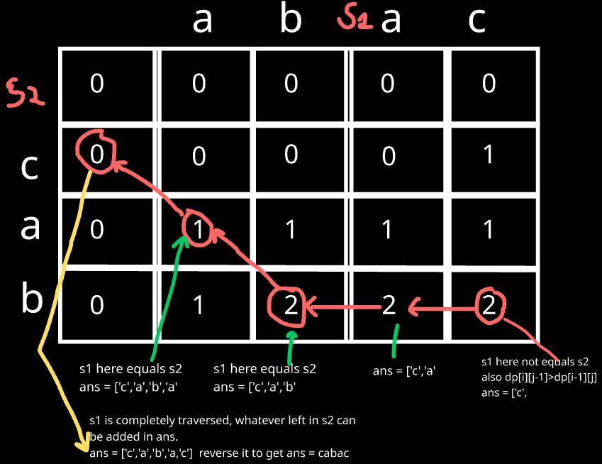
Just similar to printing the LCS.
Just change logic when values are not equal, take the value from element whose value is more.

class Solution:
def shortestCommonSupersequence(self, str1: str, str2: str) -> str:
# Step 1: Find the longest common subsequence using dynamic programming
m, n = len(str1), len(str2)
dp = [[0] * (n + 1) for _ in range(m + 1)]

# Fill the dp table
for i in range(1, m + 1):
for j in range(1, n + 1):
if str1[i-1] == str2[j-1]:
dp[i][j] = 1 + dp[i-1][j-1]
else:
dp[i][j] = max(dp[i-1][j], dp[i][j-1])

# Step 2: Construct the shortest common supersequence
# Start from the bottom right of the dp table
i, j = m, n
result = []

while i > 0 and j > 0:
if str1[i-1] == str2[j-1]:
# If the characters are the same, add it once
result.append(str1[i-1])
i -= 1
j -= 1
elif dp[i-1][j] > dp[i][j-1]:
# If coming from top has higher value, take character from str1
result.append(str1[i-1])
i -= 1
else:
# Otherwise, take character from str2
result.append(str2[j-1])
j -= 1

# Add remaining characters from str1 (if any)
while i > 0:
result.append(str1[i-1])
i -= 1

# Add remaining characters from str2 (if any)
while j > 0:
result.append(str2[j-1])
j -= 1

# Reverse the result to get the final supersequence
return ''.join(result[::-1])

Type 7: DP on Subsequence

- Longest Increasing subsequence
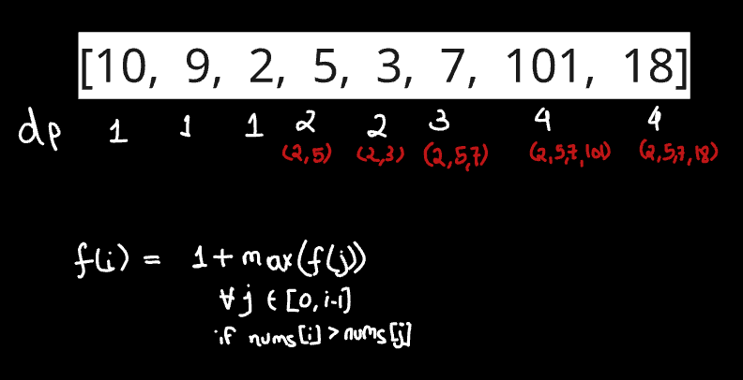

class Solution:

def lengthOfLIS(self, nums: List[int]) -> int:
n = len(nums)
dp =[1]*n
for i in range(n):
for j in range(i):
if nums[i]>nums[j]:
dp[i] = max(dp[i] , 1+dp[j])
return max(dp)

Approach 2:
This can also be done using pick and non-pick approach:
We solve this using DP with recursion + memoization.
At each index, we choose to either pick the number (if it keeps sequence increasing) or skip it.
We memoize results in dp[ind][prev] to avoid recomputation and return the maximum length found.

class Solution:
def lengthOfLIS(self, nums: List[int]) -> int:
n = len(nums)
# ind -> current index we are considering
# prev -> index of the last picked element (-1 means nothing picked yet)

def helper(ind, prev, dp):
if ind == n: # reached end of array
return 0
if dp[ind][prev + 1] != -1: # +1 shift because prev = -1 is valid
return dp[ind][prev + 1]

not_pick = helper(ind + 1, prev, dp) # Option 1: skip current element

pick = 0 # Option 2: pick current element (only if strictly increasing)
if prev == -1 or nums[ind] > nums[prev]:
pick = 1 + helper(ind + 1, ind, dp)

# Store result in dp and return
dp[ind][prev + 1] = max(pick, not_pick)
return dp[ind][prev + 1]

# dp[ind][prev+1] -> LIS starting from ind with previous index = prev
dp = [[-1] * (n + 1) for _ in range(n)]
return helper(0, -1, dp)

- Largest divisible subset
Subset: Order does not matter
Approach: We sort the array so divisibility checks work in increasing order.
Then, using DP, we find the largest divisible subset ending at each index and track predecessors.
Finally, we backtrack from the index with the maximum length to build the subset.

- Sort nums, initialize dp[i]=1 and prev[i]=i for tracking subset lengths and predecessors.
- For each i, check all j<i; if nums[i] % nums[j] == 0, update dp[i] and prev[i].
- Find index mx where dp has the maximum value.
- Backtrack using prev from mx to reconstruct the largest divisible subset.

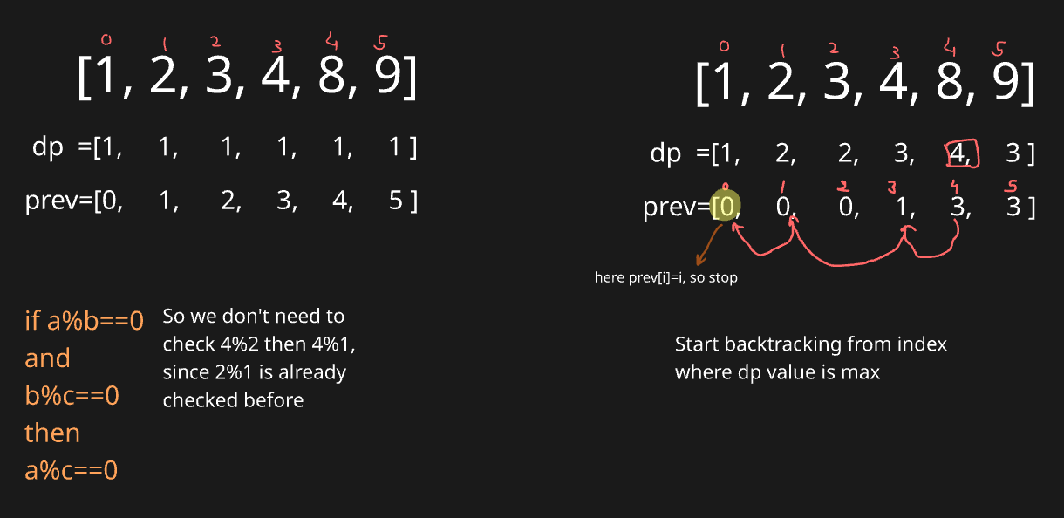

class Solution:
def largestDivisibleSubset(self, nums: List[int]) -> List[int]:
n = len(nums)
nums.sort()

dp = [1]*n #to store sizes
prev = [i for i in range(n)] #to store prev indexes

for i in range(n):
for j in range(i):
if nums[i]%nums[j]==0 and 1+dp[j]>dp[i]:
dp[i] = 1+dp[j]
prev[i] = j

#get max index where longest length is present
mx=dp.index(max(dp))

#backtrack to prev values using prev array
ans=[nums[mx]]
i = mx
while prev[i]!=i:
last = prev[i]
ans.append(nums[last])
i = last
return ans

- Longest bitonic subsequence
- Use dp[i] to compute LIS (longest increasing subsequence) ending at each index.
- Use dp_back[i] to compute LDS (longest decreasing subsequence) starting at each index.
- Traverse forward to fill dp and backward to fill dp_back.
- For each index i, combine LIS and LDS as dp[i] + dp_back[i] - 1.
- Track the maximum across all indices, ensuring both LIS and LDS exist.
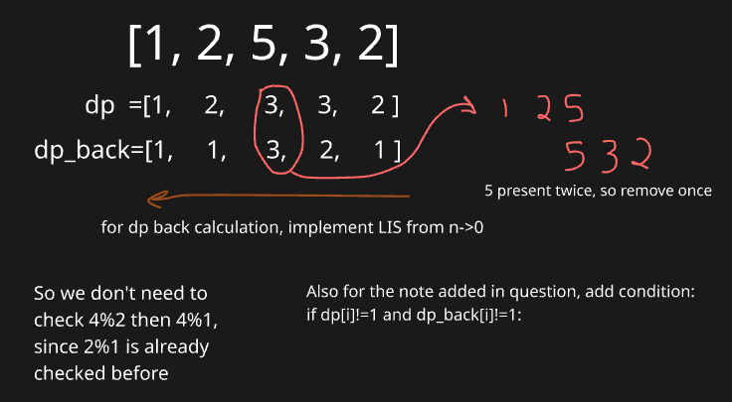

class Solution:
def LongestBitonicSequence(self, n : int, nums : List[int]) -> int:
# code here
n = len(nums)
dp =[1]*n
dp_back = [1]*n

for i in range(n):
for j in range(i):
if nums[i]>nums[j]:
dp[i] = max(dp[i] , 1+dp[j])

#in reverse
for i in range(n-1,0,-1):
for j in range(n-1,i,-1):
if nums[i]>nums[j]:
dp_back[i] = max(dp_back[i], 1+dp_back[j])

ans=0
for i in range(n):
if dp[i]!=1 and dp_back[i]!=1: #added because of note in question
ans = max(ans, dp[i]+dp_back[i]-1)

return ans
- Number of Longest Increasing Subsequence
This problem is solved using Dynamic Programming with counting:
- We maintain two arrays: dp[i] (length of LIS ending at i) and cnt[i] (number of such LIS).
- For each i, we check all previous j < i; if nums[i] > nums[j], we either update a longer subsequence (dp[i] = dp[j]+1, reset cnt[i] = cnt[j]) or add counts if another sequence of same length is found (cnt[i] += cnt[j]).
- Finally, we sum counts of all indices where dp[i] equals the global LIS length

class Solution:
def findNumberOfLIS(self, nums: List[int]) -> int:
n = len(nums)
dp = [1]*n
mx = 1
cnt = [1]*n

for i in range(n):
for j in range(i):
if nums[i]>nums[j] and dp[i]<1+dp[j]:
dp[i] = 1+dp[j]
cnt[i] = cnt[j]
elif nums[i]>nums[j] and dp[i]==dp[j]+1:
cnt[i] += cnt[j]

mx = max(dp)
ans=0
for i in range(n):
if dp[i]==mx:
ans+= cnt[i]
return ans

Type 8: Miscellaneous

- K-ordered LCS
Same as like LCS, but one new case.
New case. Now we can change k values in seq1 to make it’s i^{th} value equal to j^{th} value of seq2.
So when seq1[i] != seq2[j], then 2 cases, (1) we can use k and make both values equal, (2) don’t use k and proceed as normal. Final ans is maximum of both.
def KOrderedLCS(seq1, seq2, k):

def helper(i, j, k, dp):
if i==0 or j==0: return 0
if dp[i][j][k]!=-1:
return dp[i][j][k]

if seq1[i-1] == seq2[j-1]:
dp[i][j][k] = 1+ helper(i-1,j-1,k,dp)
else:
if k>0:
#we replacing a value in seq1,so will act as seq1[i]==seq2[j]
temp = 1+ helper(i-1 ,j-1 , k-1, dp)
#Case we not replacing any value
temp2 = max(helper(i-1,j ,k ,dp), helper(i, j-1, k, dp))
dp[i][j][k] = max(temp, temp2)
else:
dp[i][j][k] = max(helper(i-1, j, k, dp), helper(i, j-1, k, dp))

return dp[i][j][k]

n,m=len(seq1),len(seq2)
# dp of size n*m*k
dp = [[[-1 for _ in range(k+1)] for _ in range(m+1)] for _ in range(n+1)]
return helper(n,m,k,dp)

seq1 = [1, 2, 3, 4, 5]
seq2 = [5, 3, 1, 4, 2]
k=1
print(KOrderedLCS(seq1, seq2, k))

## Demo run
eg:-
seq1 = [1, 2, 3, 4, 5]
seq2 = [5, 3, 1, 4, 2]
k = 1
Ans = 3
You can change the first element of the first sequence to 5 to get the LCS comprising of the sequence (5, 3, 4)

Bottom Up
def KOrderedLCS(seq1, seq2, k):
n, m = len(seq1), len(seq2)
# Initialize the dp table with zero values
dp = [[[0 for _ in range(k+1)] for _ in range(m+1)] for _ in range(n+1)]

# Iterate through all positions of seq1 and seq2
for i in range(1, n+1):
for j in range(1, m+1):
for z in range(k+1):
if seq1[i-1] == seq2[j-1]:
dp[i][j][z] = dp[i-1][j-1][z] + 1
else:
if z > 0:
# Option 1: Replace seq1[i-1] with seq2[j-1]
replace = dp[i-1][j-1][z-1] + 1
# Option 2: Do not replace, just move in one of the sequences
dont_replace = max(dp[i-1][j][z], dp[i][j-1][z])
dp[i][j][z] = max(replace, dont_replace)
else:
# When no replacements are allowed
dp[i][j][z] = max(dp[i-1][j][z], dp[i][j-1][z])

return dp[n][m][k]

# Read input
seq1 = [1, 2, 3, 4, 5]
seq2 = [5, 3, 1, 4, 2]
k=1
# Print the result
print(KOrderedLCS(seq1, seq2, k))

- Palindrome Partitioning 2
Move from 0 to n-1, and make all possible cuts. After each cut, we get 2 halves, apply same logic on given halves and hence it becomes recursion.
K moves from 0->n-1, base condition is when i>j (not possible string, so return 0, or i==j, single character, so already a palindrome (so 0 partition required)

class Solution:
def minCut(self, s: str) -> int:
n = len(s)
dp = [[-1] * n for _ in range(n)]

# Step 1: Precompute palindrome table
is_pal = [[False] * n for _ in range(n)]

for length in range(1, n + 1):
for i in range(n - length + 1):
j = i + length - 1
if s[i] == s[j]:
if length <= 2:
is_pal[i][j] = True
else:
is_pal[i][j] = is_pal[i + 1][j - 1]

# Step 2: Apply Recursion
def rec(i, j):
if i >= j:
return 0
if is_pal[i][j]:
return 0
if dp[i][j] != -1:
return dp[i][j]

min_cuts = float("inf")
for k in range(i, j):
if is_pal[i][k]: # small optimization
if dp[k+1][j]!=-1: #if rec(k+1,j) is already computed, use that value
temp = 1+dp[k+1][j]
else:
temp = 1 + rec(k + 1, j)
min_cuts = min(min_cuts, temp)

dp[i][j] = min_cuts
return dp[i][j]

return rec(0, n - 1)

Optimization explanation:
Your original recursion was:
for k in range(i, j):
temp = 1 + rec(i, k) + rec(k + 1, j)
min_cuts = min(min_cuts, temp)

This means:
- You cut the string s[i..j] into two parts: s[i..k] and s[k+1..j].
- You compute minimum cuts for both parts.
- You add 1 cut for splitting between them.
But notice: here we are solving both halves, even if the left half s[i..k] is not a palindrome.
That’s wasteful because the only time we care about a cut at position k is when the first part (s[i..k]) is a palindrome. Otherwise, that partition is invalid for a palindrome partitioning.
The Optimization Idea
- If s[i..k] is already a palindrome, then we don’t need to compute its minimum cuts — it contributes 0 cuts.
- So instead of: 1 + rec(i, k) + rec(k+1, j) we reduce it to: 1 + rec(k+1, j) (because rec(i, k) = 0 when s[i..k] is palindrome). This avoids unnecessary recursion calls on the left half.
- Even on 1 + rec(k+1, j), in place of directly calling the function, we check if it is already calculated. So that we can use already calculated answer present in dp.

3. Longest Path
Intitution:
Each node asks:
- “What’s the longest path if I start from each of my neighbors?”
The length of the path from me is:
- 1 + max(longest path from all my neighbors)
If I have no neighbors (i.e., terminal node), my longest path is 0.

Key points:
- Only works for DAGs (Directed Acyclic Graphs).
- You are not counting nodes, but number of edges in the longest path.
- For each node, recursively calculate the longest path starting from it.
- Store results in dp[] to avoid recomputation (memoization).

import sys
sys.setrecursionlimit(10 ** 7) # else was getting runtime exceed

def longest_path(n, adj, dp):
if dp[n] != -1:
return dp[n]

max_len = 0
for neighbour in adj[n]:
max_len = max(max_len, 1 + longest_path(neighbour, adj, dp))

dp[n] = max_len
return dp[n]

# Input
n, m = map(int, input().split())
adj = [[] for _ in range(n + 1)]

for _ in range(m):
x, y = map(int, input().split())
adj[x].append(y)

dp = [-1] * (n + 1)

# Find longest path from every node
for i in range(1, n + 1):
longest_path(i, adj, dp)

print(max(dp))

